
Districtwide Distance Education Steering Committee (DDESC) – 20th Year Anniversary!
- DRAFT - Meeting Notes
Monday, May 3, 2021
12:00-1:30
Via Zoom

Members: Angela Romero, Brian Weston, Chris Rodgers, Claudia Tornsaufer, Dave Giberson, Elizabeth Barrington, Hank Beaver, Jeff Mills, Katie Palacios, Mary Kingsley, Peter Haro, Peter Tea, Poppy Fitch, Rechelle Mojica, Russ English, Sandra Pesce, and Trenton Tidwell

Announcements
Summer Teaching Shells will be available May 8th

Meeting Notes
Brian reviewed April meeting notes. Elizabeth abstained. The notes were approved without modifications. Meeting notes will be posted to the web at https://www.sdccd.edu/about/departments-and-offices/instructional-services-division/online-learning-pathways-1/faculty/resources.aspx

Camera Recommendations
The Camera Recommendations were reviewed at the March 1 meeting. Brian asked for and received approval of the recommendations that will be posted on our website. Any suggestions or alterations to the recommendations should be submitted to Brian for his consideration.

DE Handbook
Peter created a webpage that contains the downloadable DE Handbook as a word document. After Committee recommendations were implemented we had to increase pages to 37 to accommodate content formatting. As suggested, we did add language on why it is important to use Canvas. You can find the handbook at https://www.sdccd.edu/about/departments-and-offices/instructional-services-division/online-learning-pathways-1/faculty/de_handbook.aspx. Brian thanked the group for reviewing and editing the handbook. We will revisit the handbook content periodically for any necessary changes. Rules covering online conduct, is covered under AP 3100.

Katie discussed Academic Integrity as it relates to online instruction. She would like to add information on design elements, beyond policy. She provided a link https://sdccd.instructure.com/courses/2383316/pages/increasing-academic-integrity?module_item_id=39415092 that could be added to the handbook.

Claudia will meet with CCE DE Committee this Thursday (Ingrid out) and present the handbook for a second time. The group agreed that we can post the handbook now as an updated version that includes the final edits. Brian would like the handbook’s content reviewed at least every two years.

Online Learning Pathways Support (JIRA)

Chris Rodgers presented on OLP current faculty and student support. Currently, we have the Canvas Help menu, the student & faculty help support numbers, and the chat, that makes up Instructure’s 24/7/365 District support and is usually the first line of support; we still encourage using the 24/7 support. The next level of support is direct email to SDOLP on a regular basis for a variety of questions across the board, whether it’s distance education related or Canvas related. We are addressing the problem that we have with email, especially with the pandemic and work-from-home, the amount of the email load has significantly increased. With all instructors now using Canvas the need for support has dramatically expanded.

We have tried to aim our attention on request-for-support emails where we do not receive all the information that we need, whether it's an employee ID or a student ID or course number, getting all the information we need to provide the best assistance can be problematic. Over the past couple of years, we have created online forms and used a lot of Google services to try to collect necessary data and help us streamline some of our workload. From OFCP enrollments to LTI requests we use Google products. We did some research on a product called JIRA Help Desk and after working with them we decided to make the integration with this Help Desk product and throughout this summer semester we're going to be doing a beta test that Chris has developed. Instead of emailing SDOLP staff for requests for faculty, staff, and management, you will be using this JIRA form. Chris provided the group with a presentation of the pilot SDOLP support form.
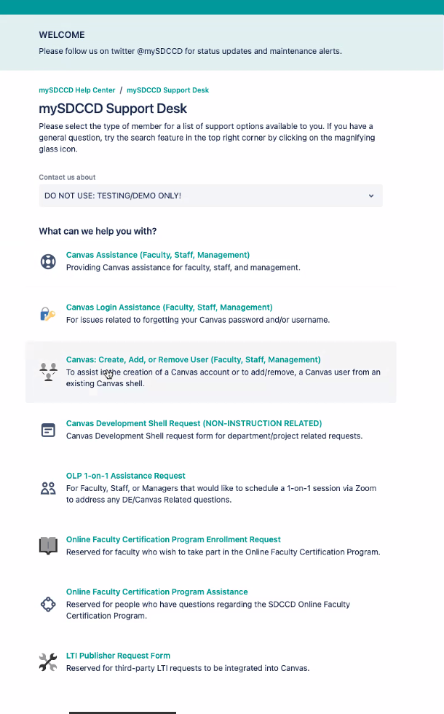

This form will not replace Canvas 24/7/365 phone/chat support. This JIRA system will be implemented to reduce and manage SDOLP email requests. Currently, the response time for email is 1-2 days, yet can extend significantly during high demand periods. It is hoped that SDOLP can implement a whole team response and provide a better, faster, and more effective service. The form will be created to intake special requests, mostly issues that Canvas cannot handle. Instructure’s SDCCD knowledge base with the Canvas Help desk has been built up over the years and is maintained by SDOLP staff. We still need to get the JIRA form backend set up properly and will be beta testing this summer and going live with the form this Fall. Brian would appreciate any feedback this group can provide.

Canvas Support 2021/22
SDCCD Canvas phone and chat support contract has been extended throughout the year. The stats show a usage of about a 50/50 phone and chat split. We intend to fund the Canvas phone helpdesk until June 2022.

InPractice @Mesa Site
Katie shared some updates on what is happening at Mesa. Mesa’s LOFT Course Redesign FIGs; Mesa's collaborative approach to equity-infused course redesign. Faculty members form their own Faculty Inquiry Groups (FIGs), and submit a proposal related to equity-infused course redesign. Once accepted, FIGs have 8 weeks to complete the deliverables. The 8-week timeline is scheduled by the Mesa LOFT each semester. Faculty are compensated for completing the deliverables of their FIG. Katie also shared Mesa’s new ‘In-Practice @ Mesa’ site, which provides resources for Mesa instructors for best course design and best practices resources. Mesa faculty share examples to make clear how to use the rubric in practice.

Professional Development

DE Week Archive
Brian thanked the members for attending DE week. He thanked Dave, Rechelle and the whole SDOLP crew. He announced that every session is available on our DE Week website. Flex availability is good to end of the year. https://www.sdccd.edu/about/departments-and-offices/instructional-services-division/online-learning-pathways-1/faculty/de_week.aspx

Rechelle noted that Judy Baker, Andrea Henne, and Kats Gustafson all made an appearance, in Brian’s welcome session. Rechelle will be sending out a post-event survey to all attendees. Overall the week went very well and we were happy with the structure and participation. Dave will continue to train and provide his very popular workshops throughout summer.

Online Teaching Conference June 21-23, 2021 | Virtual Event
InstructureCon Oct 7th, 2021
Fall 2021 Meeting Schedule: Sept. 7, Oct. 4, Nov. 1, Dec. 6

Respectfully Submitted by: DO/ES/SDCCDONLINE - Mary Kingsley

