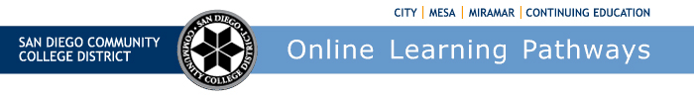
Districtwide Distance Education Steering Committee (DDESC)
Meeting Notes
Monday, October 2, 2023
12:00-1:30
Via Zoom

Members: Aileen Gum, Anne Gloag, Angela Romero, Brian Weston, Brian Palimiter, Chris Rodgers, Claudia Tornsaufer, Dave Giberson, Denise Maduli-Williams, Devika Chhabra, Desiree Payne, Donna Eyestone, Ingrid Greenberg, Iris Lowe, Katie Palacios, Kelly Spoon, Kimberly Lacher, Liesl Boswell, Mary Kingsley, Maureen Curry, Michelle Gray, Peter Haro, Peter Tea, Poppy Fitch, Rechelle Mojica, Robbi Ewell, Russ English, Sandra Pesce, Sarah Dunn, Stephanie Johnson Shipman, Susan Topham, Trenton Tidwell, and Tucker Grimshaw

Meeting Notes

The group reviewed the meeting Notes September 11, 2023

Updates

Brain announced Liesl Boswell, the new SDCCD Instructional Design Supervisor for SDCCDOLP. He talked about her experience with CVC-OEI as their Instructional Designer and her experience from the state Technology Center. The DDESC members introduced themselves.

AI Review - TurnItIn Status

Brian is looking at academic honesty and AI. Though we have a policy that is fairly robust and set, we just want to check if there's anything that does need to be modified.

TurnItIn has temporarily enabled an AI detection tool. They will remove the feature on December 31, 2023. There is research coming out about the effectiveness of this tool.

A survey coming out of Michelle’s office regarding AI and VR. Michelle shared that we are hoping to understand the interest and concerns on the campuses and her team will be happy to receive and provide feedback. She shared that the more data we have, the better proof is for necessary support. Please consider taking the innovation survey in the next couple of days. AI Survey: https://sdccd2.qualtrics.com/jfe/form/SV_8l9zytDYnKd3NnU

CVC POCR

The State’s POCR via the CVC OEI has been promoting faculty helping other faculty align their course to the CVC Rubric. It is a great professional development opportunity and we have seen increases in success rates for the courses that have been aligned across the state. There's a CVC POCR meeting that is going to occur later this week with your POCR Leads at each one of your colleges. Our current support has been set up with our Accessibility Mentors and our Online Faculty Mentors. We are working on how we can best proceed with the instructors who would like to get their course badged and aligned to CVC Rubric. Once we've completed this process, where we align courses and norm, the state will recognize our District and our colleges as being POCR-certified. At that point, colleges can begin their own local process with faculty meeting with other faculty to align their courses for the badge. We can then locally badge the instructor.

Accreditation

A quick accreditation update. The District is going through an accreditation. The State has selected courses at a random percentage of 5% of distance education courses for each one of the credit colleges. We did not go over 50 courses and we have 21 DE courses selected from City, 40 for Mesa, and 21 for Miramar. Brian thanked Liesl who created sub-accounts and enrolled all the accreditors for them to get in those courses so they can start reviewing. The accreditation process is starting from here. Brian said that we have done a lot of incredible work to get us set up and prepared. Also, our updated Distance Education - SDCCD AP 5105 has been officially approved as of September 8. Our accreditors are going to be reviewing us off our previous AP 4105 accreditation on RSI. A reminder that AP 5105 was updated to more closely match language to what the state and federal requirements are for regular and substantive interaction (RSI.)

Website: The following Administrative Procedures are being put forth for approval as part of the Board’s ongoing 6-year comprehensive review of all Board policies and procedures
https://go.boarddocs.com/ca/sdccd/Board.nsf/files/CVDLVT57569A/$file/Procedures_Ch%204%20Instructional_DGC%2009062023.pdf
Distance Education Dashboard Distance Education Outcomes Dashboard

The District Office of Institutional Effectiveness published a Public Dashboard using Tableau below:

https://public.tableau.com/app/profile/sdccd.institutional.reseach/viz/DistanceEducationOutcomes/DistanceEducationSuccessRates

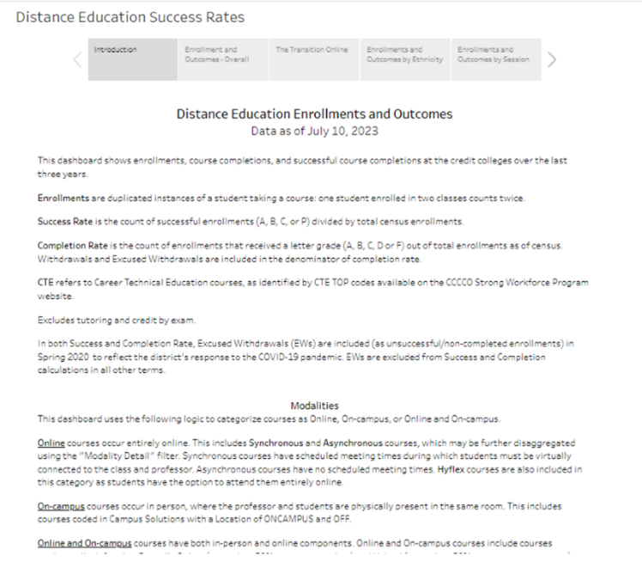

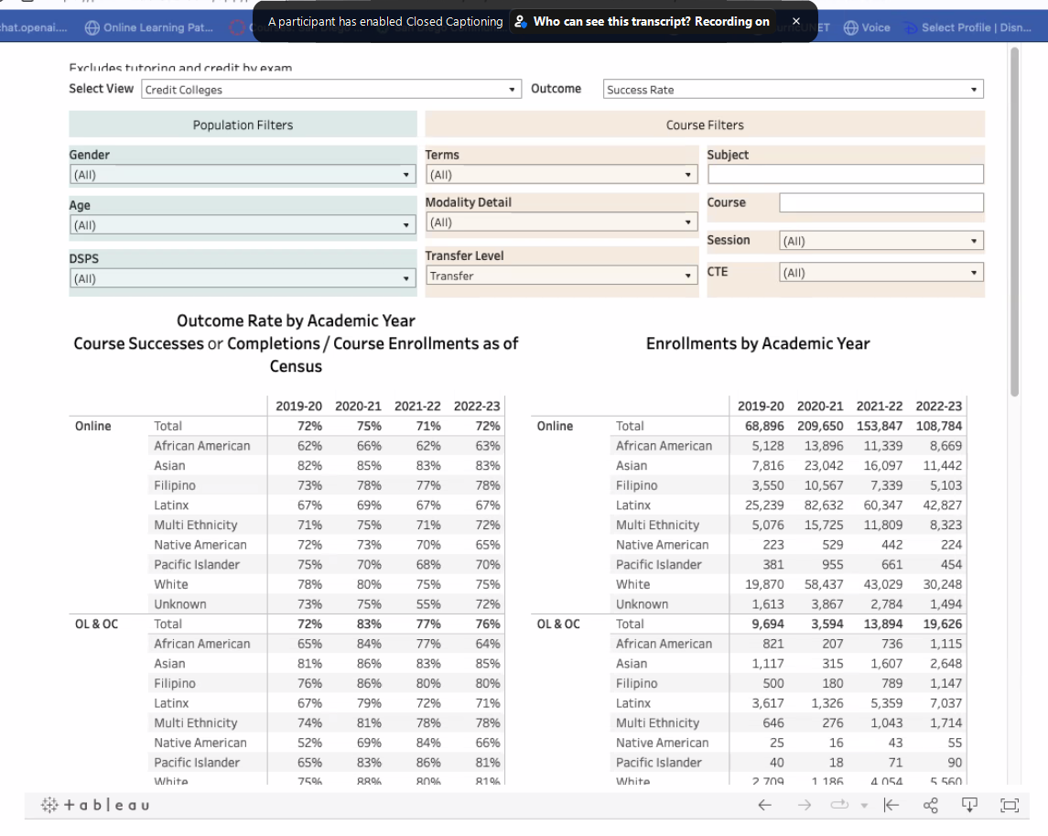

The group reviewed the site and the data where you can explore trends and compare information from year-to-year.

DE Survey

We have a DE Survey going out to all faculty and students. We are fine tuning the survey and should be ready in the next couple of weeks and should be going out by the end of the month.

Professional Development

We have SDCCD’s DE WEEK coming up 10/9/-10/12/23. We will host the following workshops:

A Leap Towards Bridging the Digital Divide
Accessibility and the Canvas Mobile App
AI
Building Better Learning Experiences: An Active Learning + Digital Literacy Approach
Building Formative Assessment into your Content Pages
Creative Commons
Cultivating Community All Semester: Strategies for Asynchronous Classes
Evaluations coming up? MOST’s Course Checkup to the rescue!
Glam-Up Your Homepage
Keynote Address
LIBRE TEXT WORKSHOP All Libretexts libraries are accessible to everyone via the internet, completely free.
PlayPosit
The HyFlex Solution
Welcome and Opening Remarks

Announcements

Single Sign Feb 16-19 Campus Solutions and Canvas

Faculty Responsibility for Equitable, Accessible Learning Environments

Next Meeting: November 6, 2023

Respectfully submitted: Mary Kingsley, SDOLP

