
Districtwide Distance Education Steering Committee (DDESC)
20th Year Anniversary!
Meeting Notes
Monday, May 2, 2022
12:00-1:30
Via Zoom

Members: Aileen Gum, Anne Gloag, Angela Romero, Brian Weston, Brian Palimiter, Chris Rodgers, Claudia Tornsaufer, Dave Giberson, Denise Maduli-Williams, Ingrid Greenberg, Iris Lowe, Jeff Mills, Katie Palacios, Mary Kingsley, Maureen Curry, Michelle Gray, Peter Haro, Peter Tea, Poppy Fitch, Rechelle Mojica, Robbi Ewell, Russ English, Sandra Pesce, Sarah Dunn, Susan Topham, Trenton Tidwell, and Tucker Grimshaw

Meeting Notes
The group approved April 4, 2022 Meeting Notes. Trenton moved to approve, Michelle seconded.

OFCP Report (Peter Tea)

Peter Tea, Project Analyst SDOLP, has been working to gather OFCP data for the District. He reported that the 2021-2022 OFCP cohort has 133 faculty that are currently enrolled with 36 faculty completing certification. In the next few months he will be sending out reminders to participants on completion deadlines. Next year’s 2022-2023 cohort will begin July 1 with early enrollment available this June.

SDOLP will be reviewing and updating the entire OFCP course. We expect updates on the new Zoom accounts and RSI information that will be added to the course. Also, incorporating the new accessibility information on our website. Peter shared that module three of the OFCP covers the Peralta Equity Rubric added by Trenton for the 21/22 cycle.

Peter reported that for Spring 2022 the SDCCD has 1,310 instructors teaching that are certified. This semester we have an astounding 77.1% of all teaching instructors certified compared to only 31.5% certification rate in the Fall of 2019. The certification rates are still climbing as we continue to enroll instructors every year. In Spring 2021 we had 451 non-certified instructors compared to Spring 2022 where we have decreased that number to 388 non-certified instructors.

Peter provided a breakdown of certifications by college:
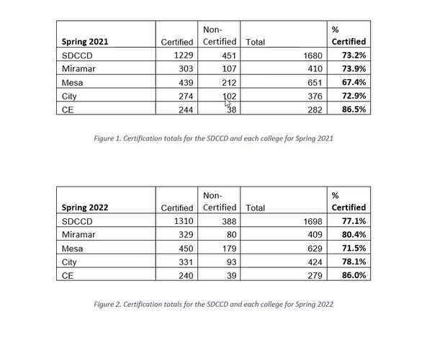
SDOLP will be working with all College VPIs and providing them names of certified instructors so that we can identify instructors teaching online who are not certified. Ingrid would like to see the list of faculty that have not yet completed the OFCP because CCE’s goal is to reach out to those individuals and match them to mentors. Brian reported that Peter’s OFCP presentation data will be included in a report to the VPIs who will share the data at their colleges. The spreadsheet that contains all certified instructor’s names is available to VPIs and though it will not be dispersed widely, the information is available to each institution. Peter added that he has been working with CCE’s Laurie Cozzolino and providing her with data on faculty currently in the training program.
Brian thanked Peter, the Online Faculty Mentors, and all the departments for supporting instructors throughout the District.

Ingrid discussed regular & substantive interaction. Specifically regarding the Federal distance education position that distance education must include regular and substantive interaction. She shared that some deans were questioning if the accreditation teams would be looking for the interaction requirement. Brian shared that Title V has been slightly modified to add ‘student-to-student’ interaction, which has been loosened up to say student-to-student interaction when applicable. It is expected that interaction requirements are documented in the course syllabi. Ingrid shared that at the CCC DEO meeting there were questions on final approval of requirements from the Board. Ingrid asked Brian to share information when it becomes available that can be used at CCE’s newly formed accreditation team committee meetings to provide guidance. She discussed that there is the legal language then there is the question on how do we make this applicable for our use. They noted that accreditation for CCE is overseen by WASP and accreditation for the colleges is overseen by ASSJC so there are differences. Brian shared the District’s AP 4105 where it spells out the RSI when applicable and lists how to demonstrate RSI.

Canvas Improvement Recommendations

The CVC and the CCMS Committee is asking for feedback. The state group that selected Canvas for CCCs has provided a list for CCC Canvas Users and asked for input as follows:

The California Virtual Campus’ (CVC) Common Course Management System (CCMS) Advisory Committee recommends new feature/function ideas for Canvas that benefit California Community College users. One way the CVC recommends new ideas is by encouraging users to rate “idea conversations” located in the Canvas Community. Instructure developers monitor the Community and pay close attention to ideas that receive the highest ratings.

The CCMS Committee recommends the following development priorities: Canvas users can rate the ideas listed

- Discussions: FunctiAdd "Reply" on to Speedgrader, allowing faculty to post a response to a student post from SpeedGrader (separately from commenting privately using assignment comments) rather than having to go back to the discussion thread to reply.
- Accessibility: Comprehensive Course Search Tool (Searching Course Content for a Topic), providing the ability for a student and teacher to keyword search throughout an entire course for a word or phrase. This would be similar to third party search tools, but would become part of native Canvas.
- Outcomes: Make meaningful the point value of outcomes used as rubric criteria, connecting rubric performance ratings (scores) to outcome achievement results. Would allow rubric scores to automatically determine outcome performance levels. Faculty should be able to grade and assess at the same time.
- Outcomes: Add Outcomes to Additional Types of Content Within Canvas, integrating assessment tools into elements of course design and creating a way for faculty to align outcomes to assignments, discussions, quizzes, content pages, etc. Faculty should be able to “tag” elements of instruction with outcomes to help them backwards design learning units/modules that align to specific outcomes.
- Course Improvement: True Surveys, gives instructors the ability to gather formative feedback from students for improvement of his/her course. This is a recognized feature of high quality online courses, and a criterion in the CVC-OEI Online Course Design Rubric.

Brian asked that this information be shared and reviewed at each of the campuses and that any recommendations be submitted as directed.

DE Board Presentation Fall

The District’s Distance Education Report was being prepared for presentation at SDCCD’s June 9 Board meeting has been postponed to Fall.

DE Handbook

The DE handbook has been updated with the changes that we have been reviewing this year. The attendance update has been implemented. We hope to update the DE Handbook with the RSI information once the wording has been finalized. We will be providing RSI examples for faculty. Brian asked the group to provide working examples and tips & tricks that we could disseminate. Brian asked that examples be sent to Peter Tea at ptea@sdccd.edu as he will be tracking examples this summer.

Katie provided Mesa's examples collected on the Mesa Toolkit site at https://sites.google.com/view/mosttoolkit/online-course-design-rubrics/section-b-interaction/b2-regular-effective-contacta?authuser=0

Passwords Technology Committee

There is a new committee run by the Vice Chancellor, the District is reviewing the standards and requirements that we use to login to our systems. We are looking at a 12-character password without expiration. This password could take the form of a short phrase. IT is hoping to roll this out on July 1 for staff and administrators. Faculty will be asked to change their passwords late August. Students will be asked at a later date and in conjunction with the student email rollout. All changes will be reviewed by DGC. Brian shared that the passwords will be self-managed and hopefully there will be little need for support. You should be able to reset your own password. IT is planning on supporting the new student emails, no new helpdesk features have been planned.

Other

Aileen reported that adjunct faculty can no longer download Microsoft 365. Brian shared that he was unaware of a difference in services for contract/adjunct. Aileen was referred to IT if she encounters difficulties. Aileen shared that she is concerned because students were told they would have access to Microsoft 365 soon. Poppy also shared that newly purchased departmental laptops are not able to download the software. Brian will investigate this issue.

Teaching Shells Available May 4th

Instructional shells will be made available on May 4. This provides about a month to prepare shells for teaching.

Upcoming Events:

- SDCCD Zoom migration happening on 7/1

- District’s TurnItIn license begins 7/1, Unicheck expires 8/26.

- Online Teaching Conference 6/29-7/1

- InstructureCon 7/14

- OpenEd Conference 10/17-10/20

Next Meeting: September 5, 2022

Respectfully submitted by: Mary Kingsley, SDOLP

,

