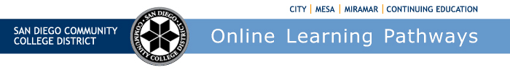
Districtwide Distance Education Steering Committee (DDESC)
Meeting Notes
Monday, October 3, 2022
12:00-1:30
Via Zoom

Members: Aileen Gum, Anne Gloag, Angela Romero, Brian Weston, Brian Palimiter, Chris Rodgers, Claudia Tornsaufer, Dave Giberson, Denise Maduli-Williams, Ingrid Greenberg, Iris Lowe, Jeff Mills, Katie Palacios, Mary Kingsley, Maureen Curry, Michelle Gray, Peter Haro, Peter Tea, Poppy Fitch, Rechelle Mojica, Robbi Ewell, Russ English, Sandra Pesce, Sarah Dunn, Susan Topham, Trenton Tidwell, and Tucker Grimshaw

Welcome

Brian discussed the recent Board Presentation on Distance Education. He thanked the Online Faculty Mentors and Accessibility Mentors for their work and input. The presentation was well received and there was positive feedback on the information provided.

AP 4105 Update

The district’s proposed Administrative Procedure (AP) 4105 is coming back for review. We have put our focus on defining RSI and excluding student-to-student contact requirement where none is necessary. Dean Hess is submitting our recommendations to all of the colleges to be reviewed and approved. Our new timeline for approval is December-January. Brian reviewed the following slide on Title 5 impact on SDCCD AP 4105:

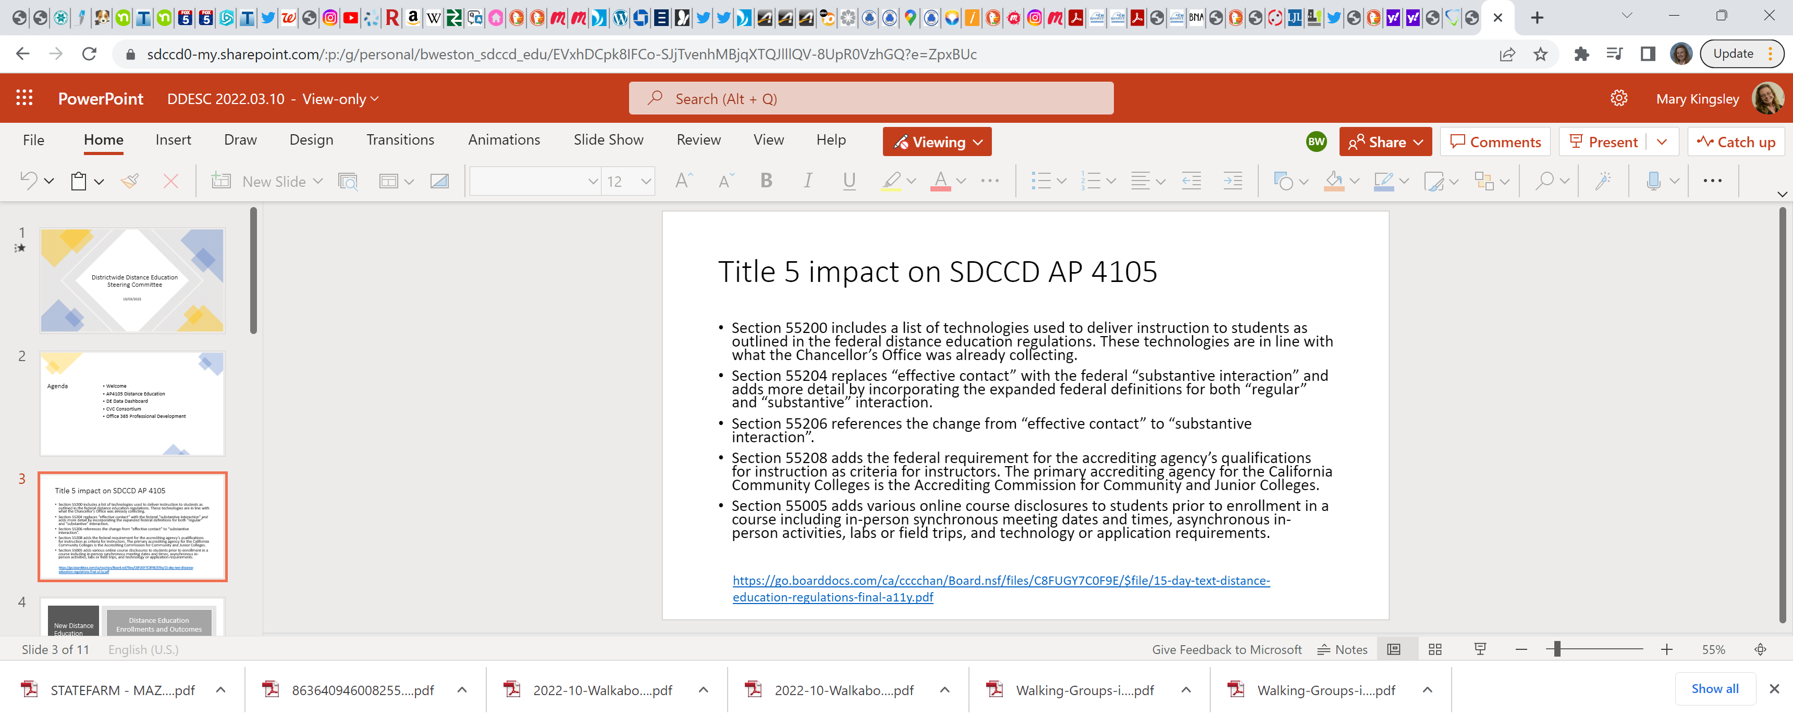

DE Data Dashboard

Stephen Bass with DO’s Institutional Research reported on Distance Education changes. He provided a presentation on what is available on the DE Data dashboard. He provided a link to the dashboard at https://public.tableau.com/app/profile/sdccd.institutional.reseach/viz/DistanceEducationOutcomes/DistanceEducationSuccessRates

The dashboard provides an overview of student enrollments and successful course completion from the credit colleges over the last three years. Stephen defined enrollments, success rates, and completion rates. He reviewed the filters that are available when using the dashboard. He added that he is hoping to add a DSPS filter so we can specifically follow outcomes for each department. Stephen is hoping to incorporate more success rate data for Continuing Education. The three main modalities are available for search and are on-campus, online, and partially online. The dashboard has four sections, enrollments, outcomes, success rates, and completion rates.

The Distance Education Update Report found in 2019-2020, just one in four enrollments were online. In response to the pandemic during spring of 2020, nearly all instruction transitioned to online. As oncampus instruction reactivated in 2021-2022, there were over 162,000 online enrollments or approximately 75% of enrollments online. Looking at online success rates, by 2021-2022 success rates returned to pre-pandemic levels of about 71%. In 2021-2022, about 75% of online courses were offered asynchronous. The study found that the gaps in success rates for African American and Latinx students were larger online than on-campus. Stephen demonstrated how you can use the dashboard to select different criteria to better study outcomes using ethnicity, subjects, and modality.

Part of the 2020-2021 Distance Education Update includes data from a student survey conducted in the Fall of 2021 with 122 responses received. Key finding was that ‘intentional efforts by faculty to communicate’ help to address the challenges brought by the distance in online courses. Next, over the last three years success rates for Latinx students were 15% lower than Asian students and the gap was 20% for African American students. In the survey, students indicated they were most likely to get help from their instructor via email and from resources posted to Canvas.

Ingrid asked if slides could note that non-credit is not included in the report. She said CCE is comprised 40% of ESL students, and ESL is comprised of immigrants and people of color with much higher success rates than the credit side of the house. She would like to see a comparison of credit and non-credit by ethnicity. Stephen will work on labeling the slides with ‘credit’ and will try to bring in the non-credit data.

Denise expressed concerns that the latest distance education report from the state was issued in 2017. Brian shared that the state is continuing to collect data and hopefully they will release a report sometime soon. The state’s report is interesting as it holds information from the other colleges and districts from all regions. The group thanked Stephen for his work on the dashboard and the presentation. SDCCD will continue to track data

Peer Online Course Review

CVC, California virtual campus, seeks to allow students to enroll in courses at other California Community Colleges. The CVC Exchange allows students to enroll in transfer courses at other CCC not currently available at their Home College to complete their general education requirements without needing to fill out separate applications for each college.
This effort provides students flexibility in finishing their coursework when courses they need are not available at their home college. The idea is they are getting information from across colleges or districts of what classes are available making it easier to pursue their education goals. To be part of the CVC consortium the colleges must sign the consortium agreement. Currently the CVC has 103 colleges that are participating in the consortium. We are currently all part of the CVC and are working towards fulfilling the requirements.
The State has put out a memo that says if you would like to continue to receive hold harmless funding at your district, you need to abide by certain requirements; one of the requirements is to join the CVC consortium. The State is providing funding for Canvas, 250 hours of online tutoring, and Canvas Studio in the 2022-23 year.
CVC - Home vs. Teaching College
A home college is determined by (a) where the student is enrolled in the current term, (b) where the student is receiving or is planning to receive financial aid and/or (c), the college from which they intend to graduate.
A teaching college is the school where a student is looking to take additional online courses to fulfill a degree program requirement that cannot be fulfilled or is less convenient to fulfill at the student’s home college.
The first step is to become a Home College. In order to become a Home College there are a lot of requirements and systems that need to be set up, A & R, Transcripts, compatible class search, and Canvas open integration. In addition, faculty must be prepared, and their courses must be aligned to the CVC rubric to be badged on the exchange. One of the requirements is that the participating college must establish a local Peer Online Course Review (POCR) process certified by CVC-OEI designed to align the College’s online courses to the CVC-OEI Course Design Rubric. They have badges that we could earn as a district/college for things such as online tutoring, and student readiness. There is a wide spectrum of support integration to become a home college. Once completed, SDCCD students will have the ability to be part of the Exchange process. It won't be until we become a teaching college that we can start offering our courses to the other students in the Exchange in a seamless operation. The CVC has been working on an update to POCR and we to hope to see what they publish as an update to the whole system. They will be adding accessibility to course review. In the past, faculty and courses were certified at the State level, they are transitioning to establish a local certification process.
The San Diego College of Continuing Education is a noncredit institution and is not listed on the dropdown menu as a home college. Ingrid has emailed the CVC to inquire as to why. Last year, working with Bob Nash, there was discussion that for all the non-credit colleges like Santa Ana and North Orange they might create a different splash page for non-credit learners, instead of trying to integrate non-credit colleges with other credit colleges. We will get clarification on the status of that work and request to be part of the next Consortium agenda. With the emergency memo, we are working on our part of the agreement.
Brian shared data from Chaffey College on student success rates. Their data shows there was a 12% increase in online course success rates after POCR alignment. Brian would like to see more data from other colleges that have gone through POCR course review, but so far, all the numbers and data sets have been positive.
Office 365 Professional Development

Brian thanked the IT department for their work implementing O365 across the District and providing professional development opportunities. IT has set up a website at https://www.sdccd.edu/about/departments-and-offices/business-technology-services-division/it/office-365/index.aspx. Student Services has created a site for students at https://www.sdccd.edu/students/student-email.aspx that reviews student email, document storage and Microsoft 365. Peter Tea and Rechelle have integrated O365 information through the SPOT student training course. We hope to provide at least baseline knowledge and baseline resources available for the students. Peter and his IT team are visiting each of the colleges to provide cyber security trainings with Microsoft guest speakers.

Announcements

  - SDCCD Online Summit Oct 14
  - Open Ed Conference Oct 17-20
  - DET/CHE Nov 29-Dec 2

Next Meeting: November 14

Respectfully submitted by: Mary Kingsley, SDOLP

