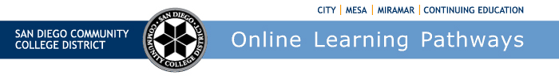
Districtwide Distance Education Steering Committee (DDESC)
Meeting Notes
Monday, December 4, 2023
12:00-1:30
Via Zoom

Members: Aileen Gum, Anne Gloag, Angela Romero, Brian Weston, Brian Palimiter, Cara Smulevitz, Chris Rodgers, Claudia Tornsaufer, Denise Maduli-Williams, Devika Chhabra, Desiree Payne, Donna Eyestone, Ingrid Greenberg, Iris Lowe, Katie Palacios, Kelly Spoon, Kimberly Lacher, Liesl Boswell, Mary Kingsley, Maureen Curry, Michelle Gray, Peter Haro, Peter Tea, Poppy Fitch, Rechelle Mojica, Robbi Ewell, Russ English, Sandra Pesce, Sarah Dunn, Stephanie Johnson Shipman, Trenton Tidwell, and Tucker Grimshaw

Meeting Notes

The group did not review the meeting notes for October 2 and November 6, 2023

CVC Peer Online Course Review (POCR)

We have just finished our second course review with Mesa College for alignment with CVC-OEI. Liesl reported that we are currently working with Miramar College on our third course. We will be working differently on the Miramar course as we will be using our own local POCR process to evaluate the course before submission to CVC-OEI. We will have one rubric that will be provided to the Miramar course and that faculty will be able to submit the course to CVC. We expect to be certified in Spring 2024.

We are a unique district because we have included the accessibility mentor support in course review. This will help us as work through A-C of the rubric. Brian added that once this alignment process is complete, it does not obligate any college to certify any certain number of courses. Although, the more courses that are certified the better. Once we get out of the gates and later in the cycle, we can start analyzing our POCR courses compared to the non-POCR-certified courses, and research has been asked to documenting increased success rates. Brian thanked Liesl and all the reviewers for their continued efforts on this large project and he shared that he is pleased to hear it's progressing nicely.

Impact Launch

Canvas has purchased EasySoft which has been rebranded as ‘Impact.’ Impact is a communication tool that is integrated into Canvas. Impact is offered to all of the California Community Colleges with a minimal startup fee. Online Learning Pathways is funding startup costs for onboarding. Once onboarded, the State will pay Impact costs. We have decided to proceed in acquiring Impact to help improve our messaging. Impact helps provide customized messaging. Instead of messaging everyone in Canvas we will be able to target specific groups. This will help us to not overload our communities with information not directed toward them. There are some built-in templates through Impact. For example, if you're a new student or new faculty, it can pop up a message as you navigate Canvas for the first time. If you click on discussion boards, for example, it could give you a little bit more information of what a discussion board is, how to navigate through it and how to properly set it up. Imagine it like a Help desk menu but built directly into the platform itself.

Also, Impact is going to provide dashboards to see just to see how well some products or some features are utilized. For example, if we see a lot of folks are using discussion boards, it can help us in tailoring our workshops to make sure we cover certain features or how to take them to the next level. If we a feature is underutilized we can help promote that tool. Also, we can realize who's using what features. As we start working on these updates for the platforms and vendors, we can then target those specific users. Right now, Canvas does not provide information on who or how many folks are using certain tools. What Impact will do is hopefully give us who's using the tool and with what courses. We're hoping to launch this starting January 2024. You'll start to see some different pop-ups in different areas of Canvas and we are hoping that we improve your experience. We will release the tools with an option for thumbs-up or thumbs-down option and you can let us know if the messages are useful.

AI Review

Brian provided links to resources. He went through some of the Canvas resources and some of the resources from Vice Chancellor Fischthal and her team.

He is looking for feedback from each college. There is news that it's coming out in a Stanford study about how AI detectors impact our non-native speakers. There's also a Vanderbilt University review where they went through and analyzed TurnItIn on how it is functioning, how accurate it was, and what the impact was on their college and their university.

There are concerns about continuing with an AI detector, TurnItIn is turning off the AI detection trial as of December 31, 2023. Brian surveyed the group for comments. City no comment. Mesa no comment. Stephanie shared that at Miramar DE Committee meetings they talked about AI and possibly having it as a standing agenda item as there are various levels of interest and concerns. Stefanie reported that Mesa faculty member, Rodrigo Gomez, had a well-attended AI workshop series that was very informative and well-received. Ingrid shared that at CCE most discussions and interest came especially in ESL and High school, and how to create lesson plans for multi-levels of literacy. The Paid subscription of Chat GPT and those who teach ESL shared it can be time-consuming when you have all levels in the same class Beginning/Intermediate/Advanced.

Brian shared that AI tools and services are going to become part of the general conversation ongoing and he will continue to monitor the topic at other task groups. The District is not purchasing any AI detector tools, but campuses are welcome to see if a detector may be suitable for the local college. He encourages conversations at the campus level and asks mentors will report back with any updates. He appreciates VC Fischthal's work in this area ‘AI Demystified’ and other workshop series being developed. Michelle thanked all for their responses that will help form spring workshops. She appreciates conversations on specific disciplines as they relate to career education and how they affect the region's industries. She has a workshop today ‘AI Demystified for Educators’ session at 4pm.

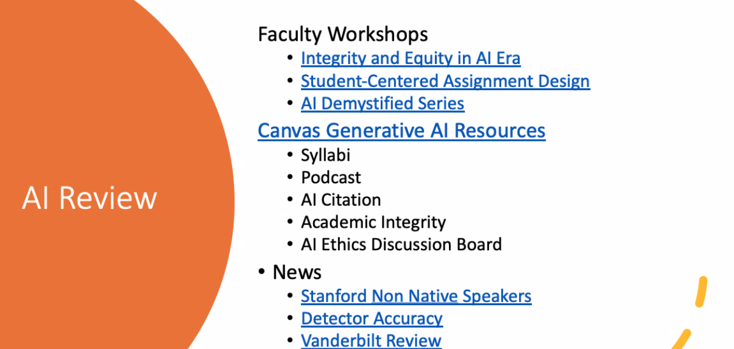

Michelle shared results from the Innovation Survey that was conducted last month and part of the purpose of that was to be able to show with data the interests throughout the district in terms of AI and emerging technologies in general, particularly in the classroom. She invited the members to reach out to her as she hopes to start building out some additional support mechanisms in terms of professional development in the area. Today’s workshop from IIE will be recorded and it will be posted on the Institutional Innovation and Effectiveness website.

Online Faculty Certification Program Design

The Online Faculty Certification Program is going through revisions to help improve and update the District’s training. It's currently rated at 20 hours for the course, and we are trying to keep that duration in the revitalization of the course.

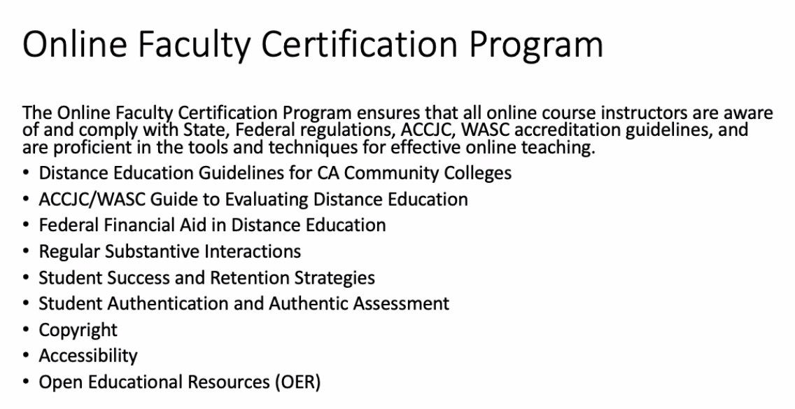

We will be keeping most of the content and we are considering options on how the training is delivered to faculty. There is a consideration to split out Accessibility and the Canvas Learning Management System into another portion of our program, possibly offering an ‘Intro to Online Instruction’ course. Keeping the OFCP course at 20 hrs, maybe 15 hrs for online instruction and pedagogy, and 5 hrs for accessibility and Canvas.

Rechelle asked for an opportunity for SDCCD recertification, necessary as many things have changed since many have certified. Brian answered that there is no current recertification at the district level. Online Learning Pathways is planning on creating a 2-3 hr course that would refresh, and update seasoned online instructors. Rechelle suggested that while we wait for the refresher course, a flex presentation highlighting some of the newest changes would be helpful. Brian shared that Mesa has started to develop a recertification course that we could look at for district-level content. Claudia asked for a shorter Hybrid model where instructors may not find need for the full course. She would like to see a lighter version of the training with some of the basics, a shorter training for new faculty members who don't see their students heavily using Canvas. Ingrid posted a link to a CCE resource for faculty that don't necessarily teach using Canvas. Ingrid would like to see High-Flex training because of the demanding challenges between the audio, the visual, and managing two student audiences… the Zoomers and the Roomers. She offered SDOLP access to content developed by and for CCE faculty held in the Creative Commons. Brian shared that he is encouraged by the work and thanked all for their input. The OFCP introduces faculty to Online Live and Partially Online fundamentals throughout the course as branches for faculty to learn from.

DE Handbook

The DE Handbook was last updated in 2022 and is already in need for an update and additional information. We are looking at ways to make the handbook interactive and friendlier. We will begin looking at the handbook in spring 24. Ingrid’s work reminds us of Zoom-hosting and new AI notes features and how they affect our ‘Camera Recommendations’ and ‘Netiquette’ guidelines. Brian welcomed help with the review of the document and assured the group that any changes will be brought back to this committee.

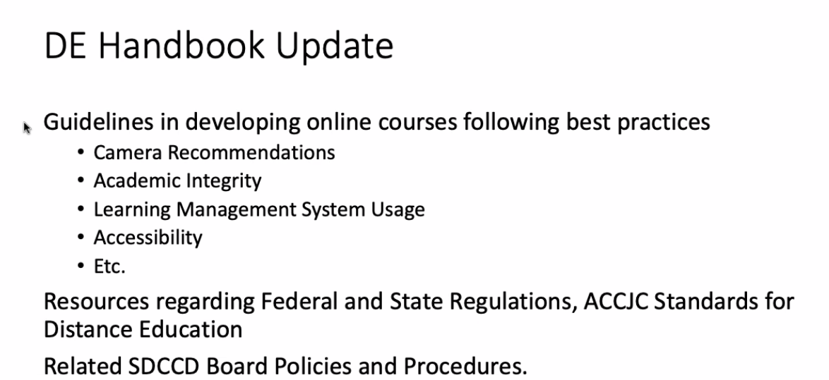

Library

All library links will be changing December 18. It will be SSO, but new proxy server, so all links will change. Sandra asked all to check links to articles and e-books. She asked for extra care to check syllabi and assignments.

Announcements:

Spring Shells Available - Spring Shells Available Nov 27th

Upcoming Meetings (Feb 5, March 4, April 1, and May 6)

CCC Online Teaching Conference Registration is now open for the June conference.

Next Meeting: February 5, 2024

Respectfully submitted: Mary Kingsley, SDOLP

