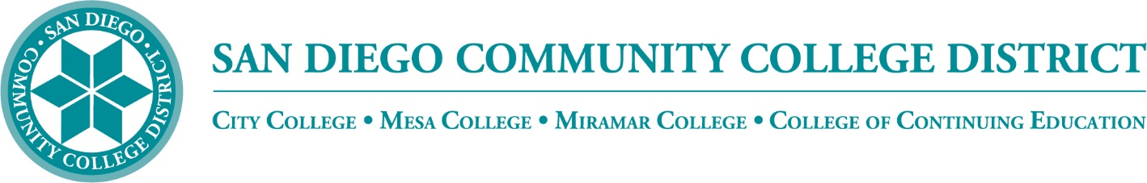

District’s Educational Services Software Workgroup
April 21, 2022
11:00 a.m. – 12:30 p.m.
Meeting Notes

Members:

Aaron Detty, Aaron Iffland, Andrew MacNeill, Anne Gloag, Brian Weston (Chair,) Cara Smulevitz, Charlie Lieu, Cheryl Reed, Claudia Tornsaufer, Darius Spearman, Denise Munoz, Elizabeth Barrington, Ingrid Greenberg, Isabel O'Connor, Jay Pope, Jill ODea, John Bromma, Katie Palacios, Kelly Rosas, Laura Murphy, Ljubisa Kostic, Manuel Velez, Matilda Chavez, Matthew Rivaldi, Maureen Curry, Michelle Fischthal, Monica Romero, Nancy Wichmann, Paul H. Alexander, Peter Haro, Peter Maharaj, Poppy Fitch, Rechelle Mojica, Robbi Ewell, Russ English, Star Rivera-Lacey, Stephanie Lewis, and Stephanie Major.

Meeting Notes

The group approved the meeting notes from March 17. Trenton moved to approve and Ingrid seconded.

STAC & STARTE
The State has decided to provide two new programs where we can purchase digital resources, educational software and solutions for our District, STAC and STARTE. Brian outlined the differences of STAC (Systemwide Technology Access Collaborative) locally-championed and STARTE (Systemwide Technology Access Resource Tools for Education) system-championed. They are very similar programs that are provided through CollegeBuys. CollegeBuys is run by the Foundation for California Community Colleges and offers discounts on a wide range of educational products, creating cost savings for the system through economies of scale. If SDCCD and/or SDICCCA found there was software that would be instrumental in helping our educational experience, CollegeBuys can research getting a discount through their negotiating power. If they were able to secure that discount that purchase would fall under STARTE. The discounts found under STAC are system-generated software solutions.
Brian shared via PowerPoint presentation the following slide that distinguishes some of the software purchases and under which group the fall under through College Buys via the CCC foundation:
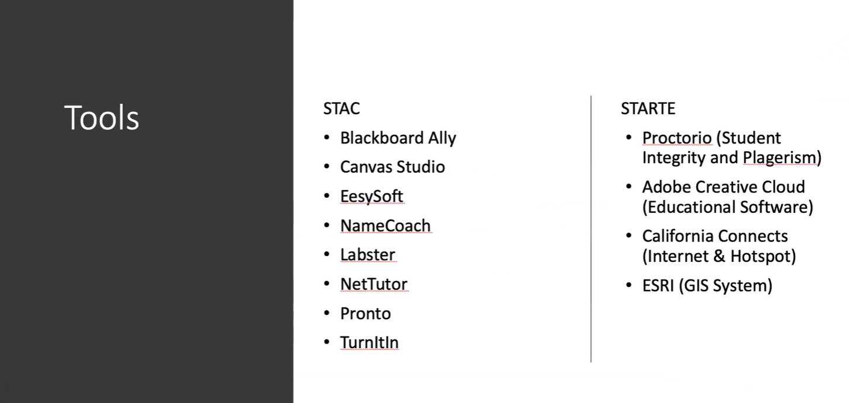

Brian added that if anybody would like to submit a proposal for a purchase he would be glad to work on the submission and help navigate the process.
Zoom Sub Accounts

SDCCD has held a few meetings with Palomar College. Palomar College is in charge of administrating TechConnect and they oversee the grant for CCC Confer. CCC Confer Zoom is provided by the California Community College Chancellor's Office. SDCCD is set to transition our zoom accounts on July 1 and will be rebranding from ‘CCCConfer’ to ‘SDCCD-EDU.zoom.us.’ There is a new website under construction that will help users with understanding the transition. The big reminder is that the transition will rebrand our zoom links. However, we are able to use the previous links. If you transition over a previous CCCConfer link that you generated for a particular meeting it will still continue to work. It is recommended that we generate new SDCCD-EDU.zoom.us as we move forward after July 1.
Jessica questioned about the recordings that we've already saved in the cloud. Brian reported that the recordings will migrate. Brian reminded the group that the State does need to moderate the size limit of the account. In the past, the State has sent out reminders and asked users to back up recordings to another system, and we'll probably see that again. We are considering a 6-month retention guideline for recordings. Instructors can use 3CMedia or Canvas Studio for instructional videos you want to host for your class. We have one more meeting planned with Palomar before disabling CCCConfer in Canvas and standing up the new Zoom LTI.
Ingrid shared her experience transitioning from CCCConfer Zoom to our District Zoom. She has been using the new account for a few weeks. So far all the features seem to be functioning and working great. She added that the user reports didn't transition over, the zoom recordings transitioned over, but not the report. Some instructors rely on those zoom reports to see which students have logged into zoom during class. She recommended an FAQ and a checklist of things to do like update your zoom software and also download any zoom reports you need before you transition to the new district account. She noted that the system does pop up with a warning, but it is good to prepare to download those attendance reports in advance. She added that the report function is working with the new District Zoom account on newly created meetings.
Katie shared that she has accepted the invite for the District Zoom sub account. She questioned whether that invite/accept action will be required by all users. Brian answered that users will be batch moved over on July 1st. It will be a smooth transition, Palomar will be moving all of our existing accounts and move them over into our sub-account. Jessica reminded the group that some users are using a different sign-in for Zoom than they use for their District email sign-in. Brian reported that IT is planning on testing the single sign-in in June in anticipation of the July 1st transition.
Katie noticed that the ‘waiting room’ settings were enabled in the new zoom accounts. The District is hoping to make the new zoom accounts as faculty friendly as possible, we will be disabling waiting rooms by default. We intend to have every meeting secured with at least one security option. If there is no security option attached, Zoom would then default to enable waiting rooms. Katie shared that it surprised her as she had not enabled that feature previously.
Ingrid confirmed that new instructors requesting zoom accounts now through July will be signed up through CCCConfer and they will transfer over in the batch on July 1. Ingrid also was surprised that she found an instructor with a new account that had restrictive settings like not being able to share screen. Brian replied that all new accounts are currently issued under the State’s settings. Brian reported that all default zoom settings are set to be as flexible as possible, any change suggestions can be sent to him for group consideration.
Palomar College will still be processing webinar licenses through TechConnect, so renewing webinar license process will not change.
Single Sign-on and Tutoring Software

For the last two years, Mark Manasse has been helping lead a district-wide tutoring team that has been reimagining the direction of district tutoring. They have been tackling issues such as how to get apportionment via tutoring, creating new tutoring courses, and how to connect a robust online tutoring scheduling and tracking system. The current system will work wonderfully if we are able to utilize single sign-on. For the last couple of years, without single sign-on, the system would not allow us to use the full aspect of the software product in use. His hope is to have input into the conversation about single sign-on. The hope is to have one set of credentials that everybody uses for all systems. Currently students are required to sign-in again and again, which makes it harder to utilize the software. His team would like to suggest that at some point in the near future the District has a full single sign-on. He offered to pilot the single sign-on with the District’s tutoring software. In Peter’s absence Brian shared that students will sign-in to one main portal screen that will allow you to access the different tiles of available resources like Email, PeopleSoft, Canvas, etc. Testing will begin in June. The District IT staff will be presenting at ESSW in May and we can request clarification at our next meeting. The tutoring centers from all colleges are on board and will are utilizing https://mywconline.com/.

Miramar Student Hub

Cheryl Barnard, Dean of Student Affairs for Miramar College and Sonny Nguyen, Assistant Dean of Outreach, presented Miramar’s New Student Services Hub page in Canvas. Miramar pulled all of the core students services areas together and organized it in a way that students would benefit. Sonny thanked Brian, Chris and Trenton for their help in setting up the new resource in Canvas.
All Miramar students that are enrolled in a class that uses Canvas have access to this hub. Faculty have the same access and are able to refer students to the resources on this page as well. Cheryl shared that the Covid emergency really pushed this effort in the hopes of helping students locate important information regarding financial aid, academic counseling, academic services, mental health, special programs, and how to be successful at college.
Miramar wanted to organize the information by how students think and talk. There was a special effort made for the site to not duplicate a webpage, but to be user-friendly and address the most common questions from students. Faculty can now point students to this resource which will save them time answering questions. This is available to Canvas users that are enrolled in at least one class at Miramar. Brian explained that within Canvas each college is in its own sub-account and we can control the theme in each sub-account allowing the offering to Miramar students. Cheryl explained that they had brought in a consultant that helped work with all departments, she met with each department to have conversations about what was needed. Each department has someone who's trained to take care of their part of the page to provide news and updates. Sonny was encouraged to report that on a daily basis they see students self-enrolling into the course.

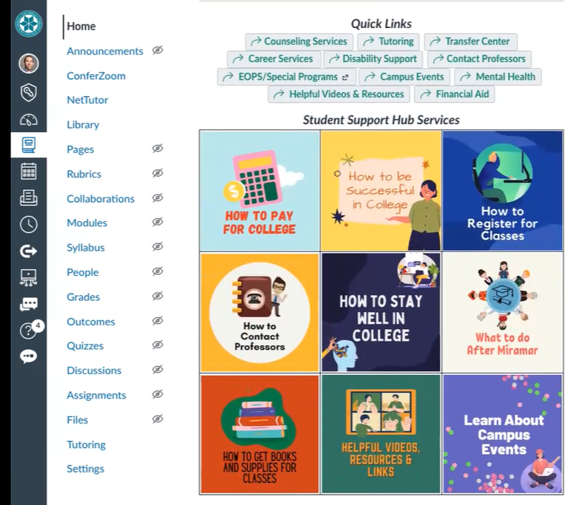

Sonny has been working really closely with each of the respective departments. They are looking at ways to continue to improve the site, so the Hub is dynamic and is of use to everyone that has it. If any group members would like access to the site, they can contact Sonny Nguyen and he will add them.

Next Meeting: Thursday, May 19, 2022

Respectfully submitted by: Mary Kingsley, SDCCD ONLINE

