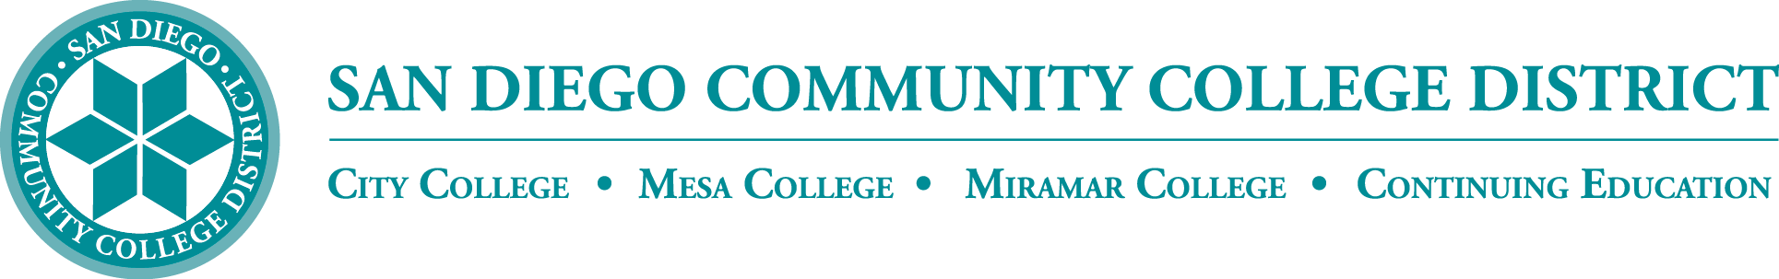

District’s Educational Services Software Workgroup
March 16, 2023
11:00 a.m. – 12:30 p.m.
Meeting Notes

Members:

Aaron Detty, Aaron Iffland, Andrew MacNeill, Amertah Perman, Anne Gloag, Brian Weston (Chair,) Cara Smulevitz, Charlie Lieu, Cheryl Reed, Claudia Tornsaufer, Darius Spearman, Denise Munoz, Elizabeth Barrington, Ingrid Greenberg, Isabel O'Connor, Jay Pope, Jill ODea, John Bromma, Katie Palacios, Kelly Rosas, Laura Murphy, Ljubisa Kostic, Manuel Velez, Matilda Chavez, Matthew Rivaldi, Maureen Curry, Michelle Fischthal, Monica Romero, Nancy Wichmann, Paul H. Alexander, Peter Haro, Peter Maharaj, Poppy Fitch, Rechelle Mojica, Robbi Ewell, Russ English, Star Rivera-Lacey, Stephanie Lewis, and Stephanie Major.

Multimedia Review update

Chris Rodgers updated the group on the Media Engagement Review Group outcomes. During the fall semester the group evaluated three products, Canvas Studio, ShareStream, and YuJa Enterprise Video. It was determined that if the state no longer provided funding for Canvas Studio that YuJa would be the best platform. YuJa came in at the same price as Canvas Studio and offers few more features. The state has indicated that the next year will include funding for Canvas Studio. SDCCD will be staying with Canvas Studio. Studio has recently updated captioning settings to allow the caption-box to be moved across the screen. Brian thanked all who participated in the review group. He added that we have close to a terabyte of media currently stored on Canvas Studio.

PlayPosit

CCC TechConnect has offered PlayPosit to colleges for a few years. PlayPosit is an easy-to-use instructional design platform that allows instructors to overlay quizzes, discussion points, and annotations over video content. PlayPosit adds active learning components to make a regular video an interactive video experience. We reviewed PlayPosit in 2021 and determined that there were many new technologies to new online instructors introduced in 2020-21. Since that time, PlayPosIt has enhanced features on top of Canvas Studio. At this time, PlayPosit integration is being introduced as an overlay to Canvas Studio. Instructors have access to more interactive discussions, provide surveys within the video as well enhanced assessments with open responses. This is a pre-announcement to let you know what is coming. We will be working with the platform in-house and are hoping to provide workshops later this spring. Rechelle discussed how H5P and ADAPT will work with the PlayPosit integration. Brian said PlayPosit is more for the video based assignments. H5P and ADAPT provide online interactions great for assessments aren’t video based. Rechelle asked if training could include the accessibility training into the professional development workshops. Trenton will make sure that happens. Although Canvas is primarily being used for instruction, staff and administrators may find it helpful for orientations, training, etc.

Software Transparency

The group discussed the current tools available to district users:

- Canvas LMS is in district use and is funded by CCC
- Canvas Chat Support is in district use and is funded by CCC
- Canvas Phone Support is in district use and is funded by SDCCD
- Canvas Studio is in district use and is funded by CCC
- Office 365 is in district use and is funded by SDCCD
- Pronto is in district use and is funded by SDCCD
- TurnItIn is in district use and is funded by SDCCD
- ConferZoom is in district use and is funded by CCC
- PopeTech is in district use and is funded by CCC
- NetTutor is in district use and is funded up to 250 hours by CCC

Brian shared a link to the District’s Software and Products available page: https://www.sdccd.edu/about/departments-and-offices/instructional-services-division/online-learning-pathways-1/faculty/software_sdccd.aspx. He asked if there are other products in use that need to be added. Rechelle appreciates having the information centralized and available on the webpage. She asked if there is a way to include a blurb to each column describing what the product is and a link to training videos describing how to use it.

State Technology

The state’s Systemwide Technology Access Collaborative (STAC) is a systemwide collaborative between the California Community Colleges Chancellor's Office, the Foundation for California Community Colleges' CollegeBuys program, and the California Virtual Campus initiative to centralize the ordering of online teaching, learning and student support tools. On the slide below the state collaborative receives a discount on the products listed under ‘STAC’ and funds the products listed under ‘System Funded.’

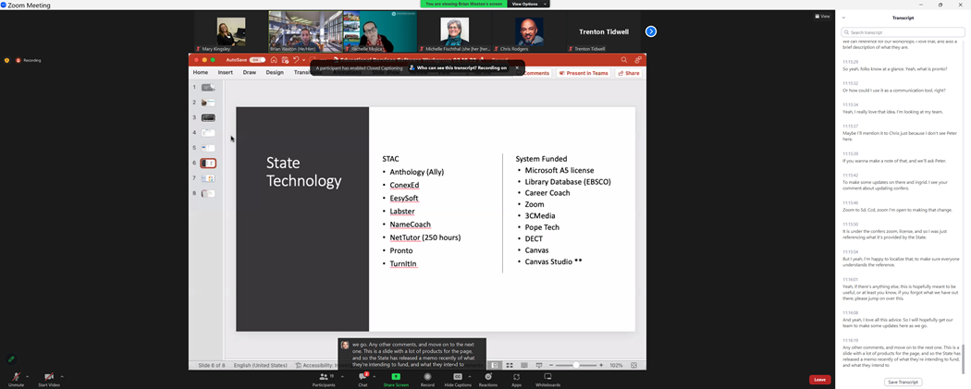

The System Technology Agreement provides discounts negotiated by the Foundation CCC. Brian reviewed the list with the group. We are waiting for official pricing on products.
Brian will work with each one of the colleges if there is any interest in getting any of the listed STAC products for their campuses. SDCCD will continue with the state funded products. The District is seeking longer 3-year contract to provide continuity for students and faculty. Rechelle suggested developing a Canvas shell with a collection of the products where faculty would be able to see what is available and view a demonstration on how to use them.

AI Detection Instruction

AI or artificial intelligence combines computer science to enable problem-solving. It also encompasses sub-fields of machine learning. We are already using AI daily when drafting emails searching the internet or using social media.

ChatGPT is an artificial intelligence chatbot developed by OpenAI and launched in November 2022. GPT-4 is already powering the new Bing, and could conceivably be integrated into Microsoft Office. Microsoft recently invested billions of dollars into OpenAI, the maker of ChatGPT. Microsoft's integration Office will include Word, Excel, PowerPoint, Outlook and Microsoft Teams. You may have already experienced AI when you type an email in Outlook and the software will guess the next word you are going to type, that is a form of machine learning. AI is going to impact everyone involved in instruction and even to our support services. There's been a lot of positive conversation associated with AI and we are looking at opportunities to embrace it and best utilize it for our students.

There is also a serious concern of how students submit information and whether it is their original information. The district is going to continue with TurnItIn and we have assembled a review group to make sure that the plagiarism detection is what we are comfortable with. Brian attended a TurnItIn demonstration and they are expecting to launch some kind of AI detection this spring. TurnItIn is working on making sure that their detection is not only detecting journals and student papers etc. but also new technology.

The plagiarism review group from 22/23 was asked to review PackBack, which is has a plagiarism detection tool as well as AI assistant, with TurnItIn. PackBack detects plagiarism in some forms however does not have a robust access to databases and journals currently. PackBack has AI built in so when students type a response, it will give students feedback of how to improve the message and how to help make sure that they're tagging and labeling citations appropriately versus just detecting where it's wrong. We will continue evaluating tools as technology progresses.

Brian let the group know that there are AI detection engines out there already. GPTZero and OpenAI are two of the sources that you can use right now to see if something has been AI generated. Brian shared the link to GPTZero that you can use to check for OpenAI and ChatGPT generated text: https://gptzero.me/ He noted that if you use Grammarly to help improve your writing, that result can be tagged as AI generated, even though the content was mostly created by human, the language generated with assistance by AI might raise a flag. Also just announced is ChatGPT4. It was reported that ChatGPT4 got a 90% on the State bar.
Google is another contender as they compete heavily with Microsoft. Google recently implemented AI tools throughout all of their products like Google Docs. Rechelle shared that Microsoft has terrific AI when creating documents and also has an integrated image creation product; you can type in a few words of an image that you want to include and if it is not within their database it will create the image for you.

Brian is interested to see what products come out and how we can utilize them to our district’s benefit. Miramar offered two great presentations that went over how they use ChatGPT in the classroom. Rechelle shared they are working on more workshops and are hoping to include students to showcase how they are using it. Rechelle said that faculty are sharing their classroom policies for using ChatGPT. Many instructors are including statements and comments about how to cite ChatGPT.

Rechelle is working with campus and faculty sharing their policy on ChatGPT here: https://docs.google.com/document/d/1RMVwzjc1o0Mi8Blw_-JUTcXv02b2WRH86vw7mi16W3U/edit?usp=sharing

Michelle Fischthal shared that the district needs to continue to focus on AI use from an administrative and operations standpoint. The President of Southern New Hampshire University spoke about education being a knowledge based industry, and how we need to be teaching humanness and relationships. Michelle shared article on humanness link here: https://www.insidehighered.com/views/2023/03/13/higher-ed-must-get-ahead-ai-paradigm-shift-opinion#.ZA8-g0rOdJ4.link

Chris shared that ChatGPT 4 was trained using data from September of 2021, it doesn't have connection to the Internet and you can't guarantee the accuracy of the information. Rechelle added that it will also operate in other languages. Helpful if someone is trying to learn another language it can be used to practice. Brian discussed our academic integrity policy. He added that it is up to individual instructors to state their preference of how students may utilize the technology in their courses.

Next Meeting: Thursday, May 18, 2023

Respectfully submitted by: Mary Kingsley, SDCCD ONLINE

