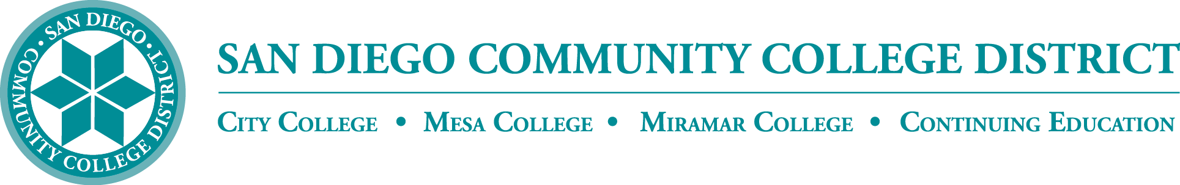

District’s Educational Services Software Workgroup
May 18, 2023
11:00 a.m. – 12:30 p.m.
Meeting Notes

Members:

Aaron Detty, Aaron Iffland, Andrew MacNeill, Amertah Perman, Anne Gloag, Brian Weston (Chair,) Cara Smulevitz, Charlie Lieu, Cheryl Reed, Claudia Tornsaufer, Darius Spearman, Denise Munoz, Elizabeth Barrington, Ingrid Greenberg, Isabel O'Connor, Jay Pope, Jill ODea, John Bromma, Katie Palacios, Kelly Rosas, Laura Murphy, Ljubisa Kostic, Manuel Velez, Matilda Chavez, Matthew Rivaldi, Maureen Curry, Michelle Fischthal, Monica Romero, Nancy Wichmann, Paul H. Alexander, Peter Haro, Peter Maharaj, Poppy Fitch, Rechelle Mojica, Robbi Ewell, Russ English, Star Rivera-Lacey, Stephanie Lewis, and Stephanie Major.

STAC Agreement

The deadline to order software via the STAC agreement is June 14, 2023. If you have any questions please reach out. The items listed are available for purchase and more information can be found here https://drive.google.com/file/d/1Yol4DA4MlwweWnua8_0d6piTgrEdAo1q/view

Instead of Ally, we have PopeTech and Accessibility Mentors. Rechelle shared her concern about funding for PopeTech and Accessibility Mentors, currently funded by DSPS. Brian assured the group that colleges can always request continued funding for the purchases of specific tools if any should lose funding down the road.

Software Students

Students and staff have access to Microsoft Office Suite. On June 28, the district will make a change and all Canvas Announcements will be sent to students’ student.sdccd.edu email. The employee accounts will be referred to sdccd.edu address. All emails will default to the district email addresses.

There will be specific announcements in Canvas and other informational campaigns on the rollout.

Brian shared a public District website explaining what software is available at https://www.sdccd.edu/about/departments-and-offices/instructional-services-division/online-learning-pathways-1/faculty/software_sdccd.aspx

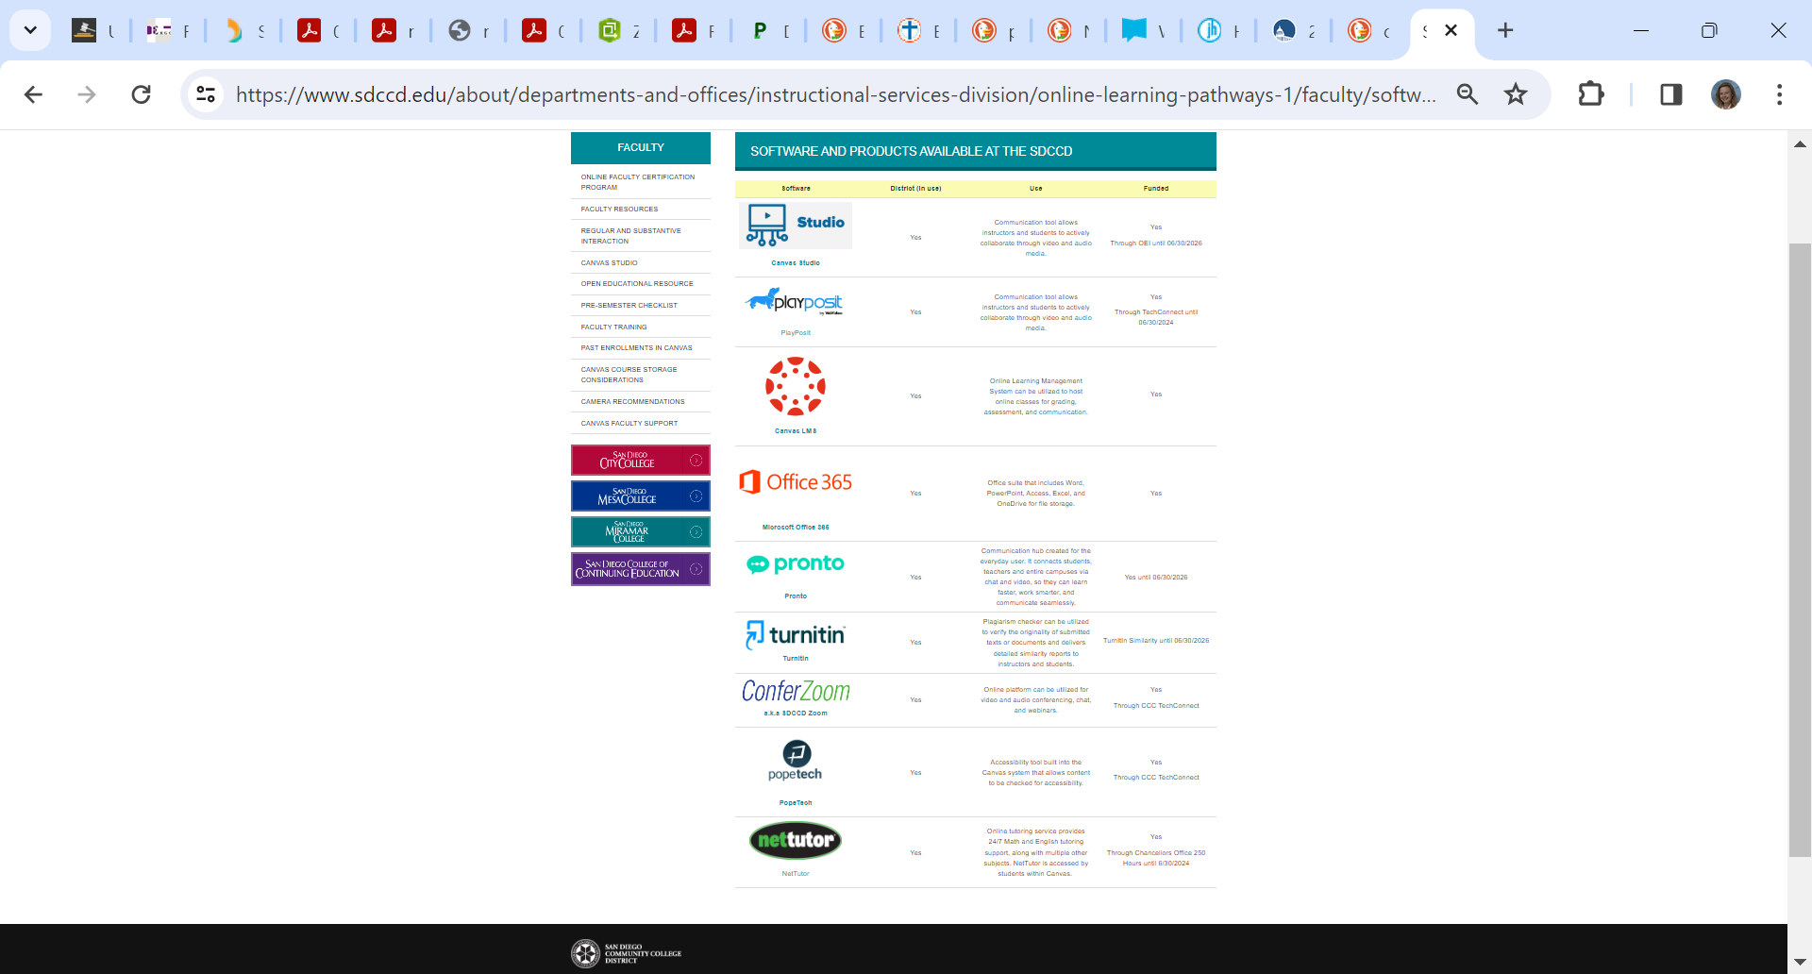

Class Room Product Zoom Overlay

Zoom continues to add features, many features are highly geared toward interactive online products. Aileen described that features such as privacy and attendance have been upgraded. City College is cautiously recommending Virtual Classroom from Microsoft Teams at https://www.class.com/

Rechelle shared Miramar’s hesitation with Virtual Classroom after a live demo. There was no trial version available. She said it is difficult to pay for a trial service when we are unsure if we want to use it. Miramar had privacy concerns in exams and quizzing. The Miramar DE Committee was not interested in moving forward.

Jessica reported that CCE Academic Senate’s DE Committee was very impressed with Virtual Classroom. The committee enthusiastically agreed to recommend it and the resolution was passed on Tuesday. The CCE Academic Senate recommended a full campus pilot.

Brian shared that pricing for Virtual Classroom was about $10k per college, if all four colleges moved forward we would get that discounted to $6k per college. Currently, both City and CCE are interested.

JWT from Zoom has been depreciated. Student Connect for Zoom and Canvas will now be safer as a more encrypted connection api is used. If you have a program that connects with Zoom it may be affected. ‘Clockwork’ a DSPS program for scheduling has been implemented and was not affected.

CCE Faculty Survey

The District conducted the annual spring survey of CCE faculty. The survey is offered via Google Forms. SDCCE Faculty Instructional Technology and Distance Education Professional Development, Spring 2023 can be found here and was asked to be completed by May 12. 2023: https://forms.gle/CrJjiS48TvCvZrwK7. Ingrid went over the entire survey results to date. She thanked CCE’s Distance Education leadership team including administrators, faculty and staff.

Announcements

Brian surveyed the group on the frequency of the ESSW meetings. Mindful of district meetings, member's time, and making sure we remain productive, we will meet twice a semester moving forward.

Next Meeting: Thursday, September 21, 2023

Respectfully submitted by: Mary Kingsley, SDCCD ONLINE, Educational Services

