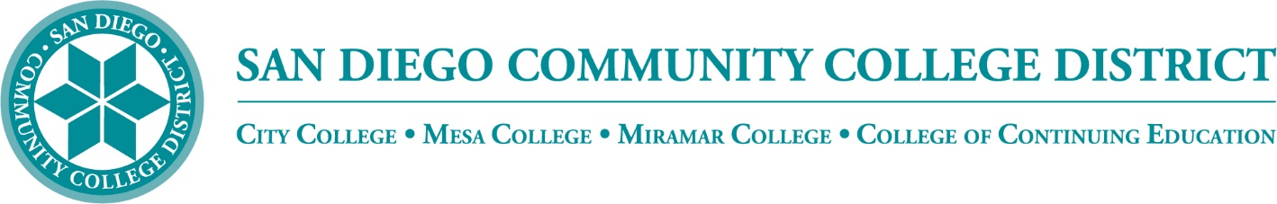

Districtwide - Student Textbook Affordability Committee (STAC)
November 3, 2022
2:00 p.m. – 3:00 p.m.
Meeting Notes

Members:

Allen Kuo, Angela Boyd, Anne Gloag, Brian Palmiter, Brian Weston, Desiree Payne, Diana Vera-Alba, Edward Borek, Lily Cava, Lisa Burgert, Nancy Wichmann, Pegah Motaleb, Rob Meyers, Sol Madrid, and Victor DeVore

Meeting Notes

The meeting notes from the October 6, 2022 meeting were reviewed. Lisa moved to approved, Rob seconded. Notes will be posted to our website for future access.

Introductions

New member Melanie Nakaji serves as an ASL Instructor and newly appointed Open Educational Resources Liaison for City College. Rob Myers, Mesa Campus Store Supervisor. Sandra Pesce, Electronic Resource Librarian at San Diego City College. Lisa Burgert, Mesa College Librarian. Lily Cava, Miramar Bookstore Supervisor. Allen Kuo, Miramar Associated Student Government President and Student Trustee for the San Diego Community College District. Nancy Wichmann, District Manager Business Services. Sol Madrid, Acting Supervisor City College Bookstore.

Instructional Material Form Update

This group has been working on a form that will let the bookstore know what materials instructors are using. We hope to improve the previous procedure of direct emailing materials requests to receive OER information. There was a suggestion to change the name of the form to ‘Reduced or Free Materials form.’ We are updating the form Question #5 to include instructional materials that are provided at no cost either by the college or by the district to facilitate our requirements to report this information to the State.

- Textbook Order Feedback (Lisa)

Nancy sent out the faculty notice for faculty to submit their bookstore orders for intercession and spring. Lisa followed up on her campus and requested feedback from faculty. Some reported that neither of the current methods worked for them. She met with a specific school at Mesa and they replied: ‘Dear STAC Committee - We would like a personalized individual email that says, Dear Professor XYZ, Here is the book you used last semester. Would you like to roll it over to this semester?’ Also, they would like an image of the book with the cost. In addition, they would like to know if the book is the newest edition. They said others institutions do this. They want it also to work within PeopleSoft, so when they see their assignment in PeopleSoft, they want the textbook order information there.

Lisa shared that the Deans are exploring whether it is possible that course materials requests can be part of the assignment acceptance process in PeopleSoft. It would be ideal if when a faculty accepts their assignment they would enter the textbook information and the course materials information along with the assignment.

Nancy questioned whether PeopleSoft can be engineered backwards to have an area included into the faculty assignment page that includes a textbook requisition area. It is very challenging for bookstore staff to vet every item. The bookstores are aware that instructors challenge why they need to update their book requests every semester. The bookstore works with instructors on course materials that are discontinued, out of print, or if new edition information is available. Nancy said if we could back engineer the data to go into another area so that instructors could see what the adoption process is and if they could program all the pertinent information that would be great. She commented that faculty who also teach at the University of San Diego, where they use a sophisticated commercial system, are comparing our process, but those systems are very costly and their students are paying the costs. Nancy will investigate what USD and UCSD are using.

Nancy also discussed instructors using PDFs without scrutiny. Because materials are easily available, some instructors are not being cautious. If it is somebody else's work, we need a document that that says you can use that work, and if you are using, you need to know how much of the book you are using. Rob commented that we could not afford to stock books without a specific order. We need instructors to give us an order every single semester. He shared that we do not have the room to carry everybody's books from previous semesters in our stores and there is a cost risk if books cannot be returned to the publisher. Rob explained that the system Lisa brought up is very expensive.

Lisa asked if we could take a look at the email that goes out to faculty and maybe streamline it, add some graphics and some images and tweak it to make the email look more engaging for faculty. Nancy assured the group that she would review any draft workups of new email suggestions. Rob added that the email has been worked and reworked many times; Received comments have been reviewed and many suggestions have been tried. Lisa brought up a suggestion of adding a quick video with directions. Nancy has provided this in the past and is willing to re-record a new video. Sol commented that the personalization of textbook orders is going to be very challenging, because it’s like asking the bookstore to do majority of the research of every instructor's book before we even know what they're using, and usually all that research and work goes in when we get the requisition. The bookstores do the majority of the research when they are entering the book and trying to acquire the book.

Brian confirmed that the reviewed changes to the form will be implemented. He looks forward to working with Lisa on constructing a new email to instructors and possibly adding a video for faculty to understand how the process works.

Low Textbook Cost Icon

Brian sent out an email with five additional options for the Low textbook Cost icon that were created using feedback from this group. He surveyed each college in the group on their preferences. Allen prefers #2, commenting it would look the best on the student portal. Sandra prefers #2 commenting on simplicity and shrinkablility. Melanie prefers #2. Lisa agreed with option #2. Desiree prefers #2 or #5. Nancy commented we might consider #5 because it is darker and would provide more contrast, Rob agreed. Brian will work with Victor on the best implementation and report back.

Option #2: Option #5: (if more contrast needed)
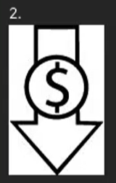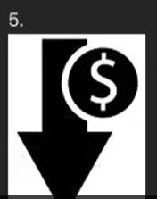

State ZTC Grant Status

We have been working on Phase I of the grant that opens opportunities for the colleges to explore ZTC, with the idea that some of that funding should go towards a tracking mechanism to satisfy XB12 reporting requirements. The State is trying to track and understand instructional material costs for our students. The State is also hoping for ZTC degrees and a full pathway experience for the student. They are also looking for regional participation; we can coordinate not only across the district, but also across the SDICCCA region. If you know anyone at your college that may be interested in collaborating on a project that would be a big advantage of any application for Phase 2 funding. The Phase 2 RFA will be coming out soon and there will be a 45-day response time. If you are interested, or you know of anybody interested, please start planning as they require data and research to back up the program, describe the impact on the region, and describe the demand for that program in the region.

Lisa would like to determine which one of our degrees across all three campuses is closest to reaching ZTC. We have already made such great progress with Math, and we could get work on general education requirements to roll it out not just for one campus but between all the campuses. Brian reminded that we could collaborate with some of our regional colleges in the area; it could be a nice collaborative project. The first round of funding was $20k for the credit colleges. There is a second round of funding that requires an approved application from the State that is looking for impactful degrees that is up to $200k. There will be a third round of the grant that has not yet been disclosed. Lisa suggested starting with our top ten degrees and survey what level of OER is in use. The district’s Community Funding Grant applications were due October 31 and are being reviewed, more information will be available in the next 1-2 weeks.

Announcements

Regional Libre Texts Workshops. The ASCCC OERI will offer Fall 2022 regional LibreTexts Workshops. The workshops will highlight the ADAPT and LibreStudio platforms sponsored by the California Education Learning Lab as free homework assessment platforms for all California instructors and students. Melanie reported that SDCCD will offer 6 hours flex credit. The daylong workshop (9:00 am – 3:00 pm) will be offered December 2, 2022.
OER Week has been announced for March 6-10, 2023 https://oeweek.oeglobal.org/.

Lisa reminded the group about the upcoming annual SB 1359 survey that needs to be completed by the ASCCC OER Liaisons.

Next Meeting: Thursday, February 2, 2023, 2:00-3:00pm

Respectfully submitted by: Mary Kingsley, SDOLP

