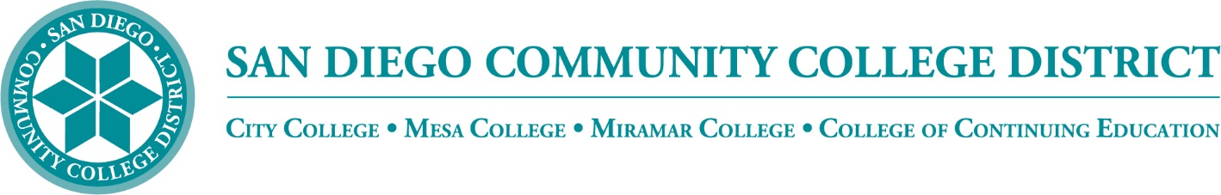

Districtwide - Student Textbook Affordability Committee (STAC)
October 6, 2022
2:00 p.m. – 3:00 p.m.
Meeting Notes

Members:

Angela Boyd, Anne Gloag, Brian Palmiter, Brian Weston, Desiree Payne, Diana Vera-Alba, Edward Borek, Lily Cava, Lisa Burgert, Nancy Wichmann, Pegah Motaleb, Rob Meyers, Sol Madrid, and Victor DeVore

Meeting Notes

The meeting notes from the September 1, 2022 meeting were reviewed and approved. Notes will be posted to our website for future access.

CCE OER Course

Diana, CCE OER Coordinator shared a presentation of the DS-SDCCE-OER-RESOURCES course available in Canvas. Instructors are greeted with a Welcome page ‘Open Education Resources, Free Resources, and Zero Textbook Costs’ which provides users with a video on how to use the course. The course works as a Resource Center for faculty. The welcome page shares a video on ‘Why use OER?’ and also promotes weekly OER Office Hours. The page also offers OER Resources to include, Creative Commons, Attributions, Finding and Using OER, OER Repositories, OER by Discipline, Free Resources, and Zero Textbook Costs (ZTC.) Diana reviewed the modules in the course. Each module offers various videos, resources, definitions, and links to information. She also ensures the information on licensing is available so instructors know how they can use each resource.

Diana has defined sections with a color-coded legend for instructors; Green – You can, Yellow – You must, and Red – You cannot for each of the licenses. She provides an archive of her workshops and presentations on OER. She is also an OER liaison for AFCCC and made available an archive of the OER Initiative monthly newsletter.

She constantly updates the site and she encourages instructors to search the course on their own. The course is full of resources that she has located and she offers resources offered by others. Diana asked group members that would like to be added to the course to email her that request. Brian thanked Diana and added that the course can be linked as a Districtwide resource.

Community Funding Grant

The Community Funding Grant is open to all colleges throughout the district to develop online and Zero Textbook Cost content. This group is developing the application to disperse funds to content creators. The application reviewers can submit their own applications, but would be excluded from reviewing their own application. Brian surveyed the group for volunteers to serve on the reviewing committee:

CFG Application Review Committee:

City – Aileen Gum online portion of the application
City – Sandra Pesce ZTC section of the application

Miramar – Anne Gloag online portion of the application
Miramar – Angela Boyd (not confirmed) ZTC portion of the application

Mesa – Cara Smulevitz online portion of the application
Mesa – Lisa Burgert ZTC section of the application

CCE – Ingrid Greenberg online portion of the application
CCE - Diana Vera-Alba ZTC section of the application

Student – Allen Kuo will be the student representative

First to be reviewed will be the five applications received to date. The grant funds will be dispersed over three years leaving about 2.5 years to review materials and award grant funds to applicants. The first round of applications should be reviewed with award announcements going out in November. After the applications are reviewed and awarded the instructor will have a timeline of two semesters or one year to complete the project. Applications will be accepted on an ongoing basis for both online and ZTC content. We expect the compensation to be awarded in tiers as follows: 1 ESU - light work; 2-4 ESUs – heavy work; and 5 ESUs for more in depth work such as an original creation.

California AB 132

California’s Assembly Bill 132 provides $115M allocated to create Zero Textbook Cost (ZTC) degree pathways for students enrolled in California Community Colleges. In Phase I, the state will provide each credit college $20k to identify and commit to implement ZTC at each college. Brian has met with the VPIs and after approval from the Board, Phase 1 funding will be bundled and distributed through the CFG Review Group. The State will be reviewing applications for Phase 2 funding. We are waiting on more Phase 2 information to be provided. We are expecting similar, but more detailed reporting requirements. There is an ASCCC meeting coming up this Friday and hopefully more information will be released.

Low Textbook Cost Icons

Brian sent two new proposed LTC icons out for committee review. The feedback received was that the icons provided did not meet our needs and should be further revised. Comments included ‘text was too small and hard to read,’ ‘there was no color,’ and the ‘icon was hard to find.’ The group preferred the ‘down arrow’ to the ‘cross mark’ on the icon. Victor provided the group a demonstration of the current Textbook Icon used in the online class schedule. These icons are made with text attached that can be picked up from screen readers for accessibility. The group can choose from over 19,000 icons and Victor shared that small tweaks can be made if necessary. Brian reported that the minimal amount of text, shapes, and colors is best received. Sandra asked that any new icon be aligned to icons already in use. Currently we are using an encircled ‘$’ in gray. Victor displayed the icons in current use in the online class schedule:

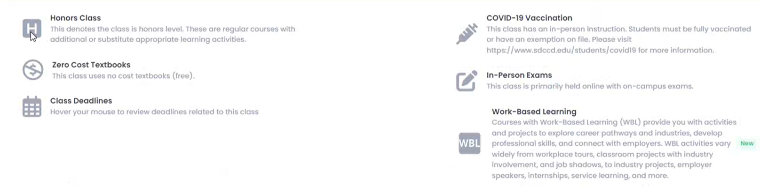

Victor reviewed the online class schedule filters. Currently students can filter by Zero Textbook Cost, we plan to change the filter to ‘Textbooks’ and have a drop down menu with the choice of Zero Textbook Cost and Low Textbook Cost. When filtering courses by ZTC, the icon appears at the end of the course name. When viewing the course schedule the icons are very small and gray which makes them hard to notice. After the group discussed, it was agreed the icon should be in color. In addition, it is possible to add ZTC information in the course description. Brian will ask Peter Tea to create an icon with the ‘$’ and down arrow for consideration. Victor asked the icon be created in .svg format for easier manipulation.

CCC - XB12

XB12, Instructional-Material-Cost, has been added to the California Community Colleges Management Information System Data Element Dictionary. The state is adding more categories to track student costs by course section. We are updating our current affordability form, adding one more category “no-cost to student, materials are provided by ______” The more we can build into our system the better we can track student costs for reporting.

Brian polled the group for their input on how to track the no-cost-paid-by-others category. Lisa shared that it should be reported with the bookstore order. Nancy agreed the information would have to come from the faculty textbook order; she added that if faculty do not report, we would have no way to track.
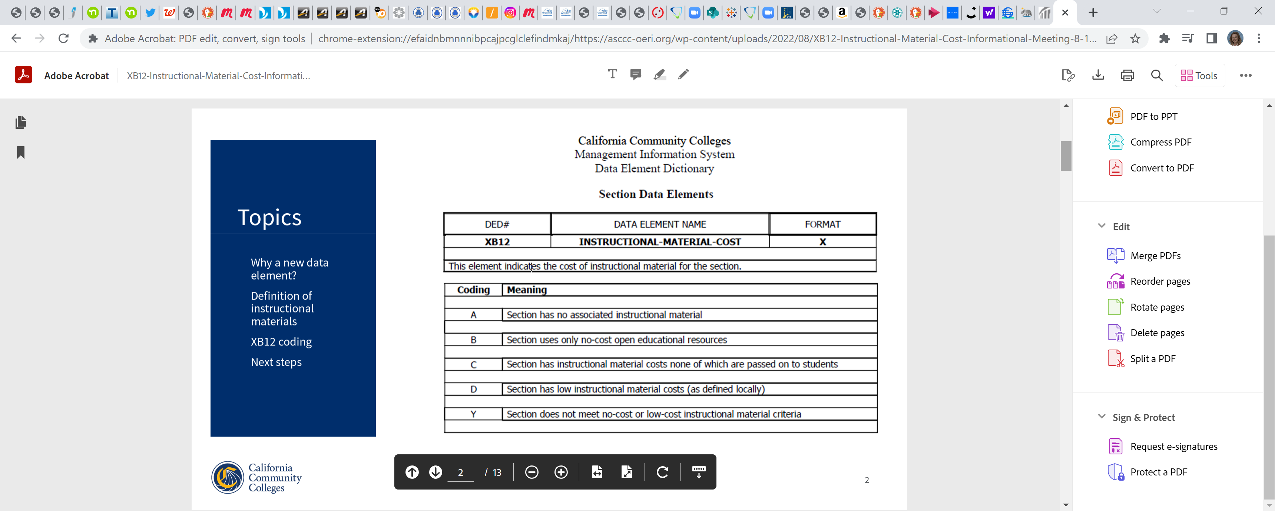
Announcement

Caitlyn from the 20 Million Minds Foundation is promoting OER and ZTC and has reached out to find how SDCCD instructors and students are benefiting from state funding. They hope to gather success stories to share with legislatures to keep the funding ongoing. Jack Beresford has approved and has been involved with community promotion to lower material costs for students. If you or someone you work with would like to share a story, please reach out to Brian for contact information.

Next Meeting: Thursday, November 3, 2:00-3:00pm

Respectfully submitted by: Mary Kingsley, SDOLP

