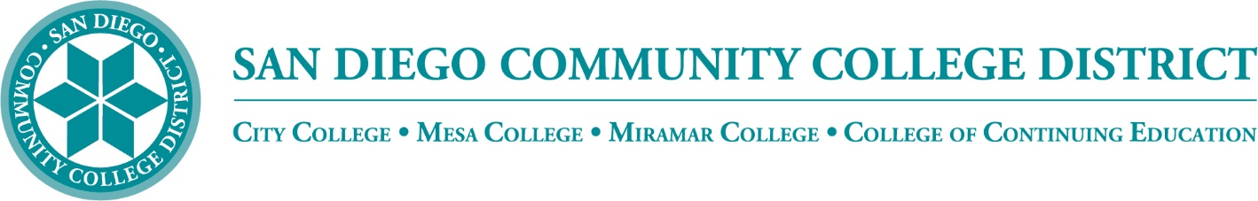

Districtwide - Student Textbook Affordability Committee (STAC)
February 2, 2023
2:00 p.m. – 3:00 p.m.
Meeting Notes

Members:

Allen Kuo, Angela Boyd, Anne Gloag, Brian Palmiter, Brian Weston, Desiree Payne, Diana Vera-Alba, Edward Borek, Lily Cava, Lisa Burgert, Nancy Wichmann, Pegah Motaleb, Rob Meyers, Sol Madrid, and Victor DeVore

Meeting Notes

The meeting notes from December 1, 2022 meeting were reviewed and approved. Lisa moved to approve and Anne seconded.

Community Funding Grant - Update

The Community Funding Grant seeks to improve OER and result in Zero Textbook Cost (ZTC) pathways for students districtwide. The committee worked throughout the fall and has reviewed and approved 15 projects to date. We are considering a Round 2 of applications this spring.

Brian announced a new OER Faculty Lead, Kelly Spoon from Mesa College. Kelly will be assisting faculty with support and keeping up with approved timelines. She will also be working with Brian on reporting and documentation. Brian shared that Maddie (Madeline) Button has been hired as a specialist to work on OER and she will be reviewing current projects to see how she can assist. Kelly and Maddie will play an important role in supporting our instructors as they develop materials and convert courses to utilize open resources.

H5P Functionality

The district has received requests for H5P availability. H5P is a costly plugin tool that helps produce and run interactive content and interactive video within a LMS. It allows you to add video with text questions in the same frame. Luckily, the state has offered H5P through a LibreText grant and also a new product called Adapt. In addition, we have established Adapt in our current Canvas system for instructors to use. Diana noted that she was required to use her SDCCD email to access the free product through the OERI website. Brian is hoping to create professional development workshops in the future. Lisa provided a link to H5P webinars that are archived on the ASCCC OERI website found here https://sdccd-edu.zoom.us/j/83205568327?pwd=cEFPak1sMFEvOTNBVGNEeVBMOGZzUT09

OE Week

OE Week is March 6-10, 2023. Brian reached out to the group and asked for presenters and OER trainers. Rechelle Mojica will be working with Brian on scheduling the weeklong event. He added that it would be great to have a H5P workshop and Student Panels if available.

Book Vouchers

OERI is looking at how textbook vouchers are issued to students, and how they are able to use them for their classrooms. In the past, the students that were provided vouchers would have to use the vouchers at the college bookstores. If students could not find the materials at the bookstore, they were required to purchase out of pocket and request a reimbursement via the financial aid office. We are hoping that the vouchers will be able to be used at other vendors; it may depend on the voucher funding that may have restrictions on use. Lisa has reached out to the bookstore to find out the process.

Low Cost Textbook Search

Victor is currently working on programming with IT to enable a low-textbook-cost search in the class schedule. He is hoping to complete this task this semester. He noted that the search is also required for reporting to MIS.

Announcements

Diana announced that she completed the Creative Commons Boot Camp the first week of January. She is now Creative Commons certified. She said that it was a lot of work, but a great experience. Lisa shared she went through the librarian track and is also certified.

Next Meeting: Thursday, March 2, 2023, 2:00-3:00pm

Respectfully submitted by: Mary Kingsley, SDOLP

