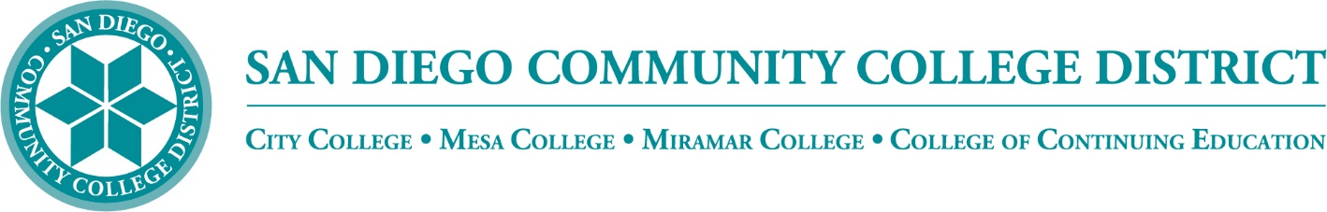

Districtwide - Student Textbook Affordability Committee (STAC)
May 4, 2023
2:00 p.m. – 3:00 p.m.
Meeting Notes

Members:

Allen Kuo, Angela Boyd, Anne Gloag, Brian Palmiter, Brian Weston, Desiree Payne, Diana Vera-Alba, Edward Borek, Lily Cava, Lisa Burgert, Nancy Wichmann, Pegah Motaleb, Rob Meyers, Sandra Pesce, Sol Madrid, Poppy Fitch, Melanie Nakaji, Kelly Spoon, Victor DeVore, Allen Kuo and Scott Kraus

Meeting Notes

The meeting notes from March 2 2023, meeting were reviewed. Nancy invited from the bookstore.

Welcome

Brian congratulated the colleges for their participation in the American Association of Colleges and Universities’ (AAC&U) Institute for Open Educational Resources (OER) application process. Notification has just been received that City, Mesa and Miramar colleges were all accepted for the Institute of Open Educational Resources, a year-long training program on designing and implementing OER plans on campus.

State Acceleration Grant Summer

The Chancellor’s Office released Phase 1 grants (“ZTC Planning Grants”) through district apportionment in July 2022. California’s 115 colleges each received $20,000 to begin planning the development of a ZTC program, additional information can be found in the 2022-23 Compendium of Allocations and Resources. Colleges will need to review the ZTC program assurances and complete their certification in NOVA by March 31, 2023. Fiscal reports are due in NOVA by June 30, 2023. To be eligible to receive or apply for subsequent phases of the ZTC grant, all items in NOVA must be completed.

Phase 3 grants (“ZTC Implementation Grants”) are the follow-up to the ZTC Planning Grants mentioned above to support all colleges with the development and implementation of the planned ZTC degree programs. In March 2023, 115 colleges will receive an additional $180,000 through district apportionment to design, develop and pilot a ZTC degree offering. Using the NOVA platform, colleges will need to submit a work plan by October 2023 and complete implementation and reporting by December 2024. The Chancellor’s Office will communicate to all colleges and districts the availability of the work plan in NOVA

What was formally known as Phase 2 will be titled “ZTC Acceleration Grants” going forward. They are competitive grants and intend to support the acceleration in development and implementation of ZTC degree programs by those colleges and/or districts that are ready. Interested colleges and/or districts will apply by responding to the Chancellor’s Office’s Request for Applications (RFA). Applicants will provide details about their proposed ZTC program(s) and self-assessments of their institutions’ capacity to support that effort. The RFA will be released in Fall 2023, and awardees may receive up to $200,000 for each degree development and implemented. The application, review, and selection timeline will be articulated at the time of the formal release of the RFA.

The State has talked about releasing Round One of the $115M. It may come out sooner than anticipated and it may be as soon as this June. We need to be prepared to receive the $200k amount for the creation of ZTC Pathways being released in the summer, it is now time to think about what may be of interest to each college. Brian will release the RFA in June or the original offer in August.

Community Funding Grant - Round 2 Open

The Community Funding Grant Review Group successfully ran Round One with the first 16 applicants. Kelly Spoon and Maddie Button have been working with applicants and have developed updates adding specificity to the application form for Round Two that has already been sent out to all of the colleges. The CFG Review Group will start scoring the second round of applicants soon. This will allow faculty to work on their OER projects over the summer. The due date for Round Two applications is May 9th, with scoring taking place May 10-17th. Kelly asked members of the first review group to provide feedback on Round One application process and specifically on the OER scoring rubric. Kelly and Brian are currently seeking qualified faculty to serve on the Round Two Review Group.

SPARK

Diana shared information on the Michelson Spark Grants. There will be an informational webinar on May 18 10:00 am to provide an overview of the Spark Grant program. The Michelson Spark Grants are $25k are for developing processes for Open Educational Resources (OER) development. The application will be open from May 30-June 13. More information and registration for the webinar can be found here https://us02web.zoom.us/webinar/register/WN_2XszWdDbQQGZl9yx-dWfkA?_hsmi=256647544&_hsenc=p2ANqtz-8QUMEMw5hXR0GPCJR79NEBN1lA0MVKZunjvQSqglOPEXVSZW2_uohuzy5FVG9iu5dXa4u0PkHV85fxzw4WW6_6BusyoA#/registration

Affordability Report Review

Brian displayed the updated Affordability Report file. The report is provided to the Board every year to recognize and showcase the progress on cost savings for students throughout the district. Brian thanked members for their contributions to the Affordability Report. Together we were able to collect a mass amount of information. The colleges Fall 2022 report estimates a total OER/ZTC cost savings to students of $2,640,179. This year the report will be finalized and distributed to the VPIs and VCs for their review.

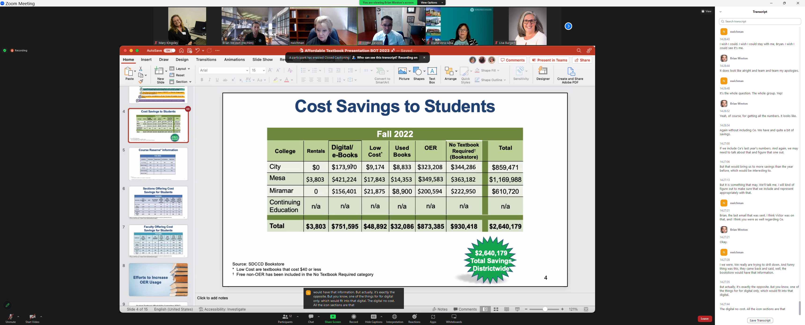

The group discussed Materials on Reserve at the college libraries. Brian thanked Lisa for pulling the large amount of data collected. Previously we were not able to collect that information due to Covid and the ability for students to access the reserves was limited.
Lisa shared that the checkouts numbers are lower than normal because all students had not returned to campus after the pandemic. She described the ‘digital scan’ column is used when faculty provides a scan of materials and makes those materials available at the library.

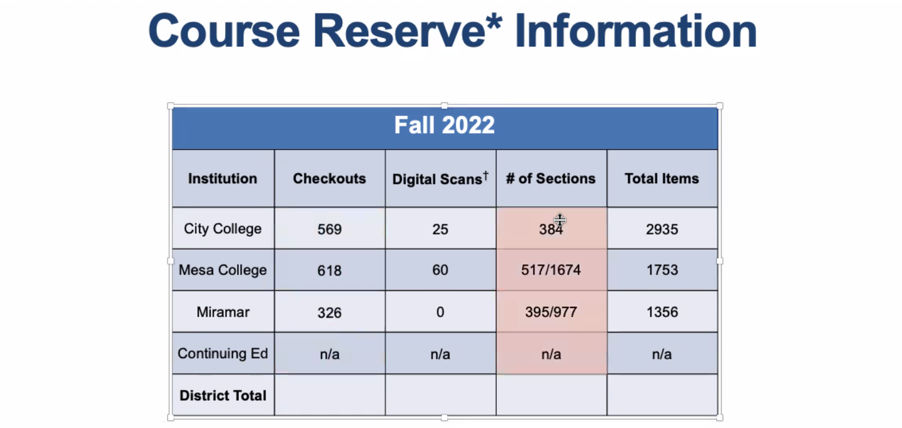

The number of sections still needs to be reviewed. We have the ability with our new system to see how many sections are using textbooks and how many sections have course materials on reserve.

Brian shared that CCE was not able to participate in books on loan because they are not provided via the bookstore, materials are provided locally within the departments. Brian asked CCE how we could document and showcase that information Nancy noted that 90% of CCE courses are low or no-cost. Brian will meet with Diana to discuss options for the report. Brian thanked Peter Tea for his efforts using the Enrollment Management System to pull much of the necessary course data showing 20% of courses using OER/ZTC. We are looking at different opportunities to more accurately report cost savings. Brian is looking at Ty Consulting to track ZTC Pathways using part of the ZTC Grant funds. Brian is also looking at ZTCPathways.com. Brian asked Kelly to work on the CFG slide and provide any data that would be helpful.

ZTC Categories Tracking Free
No materials
Digital Materials

We are working on getting updated information in the system for ZTC or under-$40 sections. The State is also updating the MISXB reporting requirements. CCE has also requested the same class search functions for their courses. Victor reported that the Student Services side is ready and they have submitted the request for coding to IT. We have quite a few projects that are being worked on by IT, and this project is in the queue.
.
Brian met with the VPIs and asked them for the ZTC Round One funding to support OER applicants and assist us in tracking ZTC pathways. We will bring on TY Consulting to perform analysis using data from all three colleges.

OER Week Webpage

Our OER webpage has received 89 viewers. Brian will turn to all VPIs and VCs to give them an idea on what we are doing with OER and ZTC Pathways efforts.

Icon Update

We are working with DO Research department on an OER survey that will hopefully run parallel with the DEA survey. Our department is able to survey once per year so we have had to alternate. The DE survey is a must, but we do not want to exclude ZTC. We are looking for a way to incorporate ZTC into the DE survey. We can survey different groups, but large institutional research reports may be delayed. Brian is hopeful for ZTC (like DE) dashboard to run courses and find out success rates etc. If we this group is interested we will revisit this group for input.

Next Meeting: Thursday, September 7, 2:00-3:00pm

Submitted by: Mary Kingsley, SDOLP

