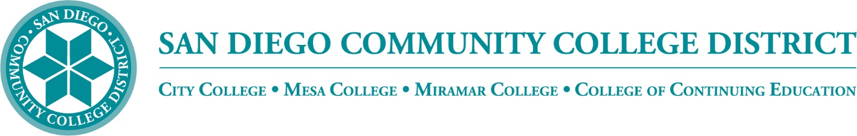
Districtwide - Student Textbook Affordability Committee (STAC)
February 7, 2024 2:00 – 3:00 p.m.
Meeting Notes
Members:

Allen Kuo, Angela Boyd, Anne Gloag, Brian Palmiter, Brian Weston, Desiree Payne, Devika Chhabra, Diana Vera-Alba, Edward Borek, Kelly Spoon, Lily Cava, Lisa Burgert, Maddie Button, Melanie Nakaji, Nancy Wichmann, Pegah Motaleb, Rob Meyers, Sandra Pesce, Scott Kraus, Sol Madrid, and Victor DeVore

Cash Management Regulation

We are reviewing the federal-level legalese from the US Department of Education - Office of Postsecondary Education about Cash Management Regulations. This is something that doesn’t directly impact us, but it comes close as we discuss inclusive access. At the federal level, there may be changes in funding requirements regarding the inclusive access process that might claw back the rights of students and their ability to take college classes. The USDE is releasing information and requesting feedback as it seeks to limit colleges' and districts' ability to include the cost of books and supplies. The rationale they are using is concern over the lack of disclosure and transparency of costs which could limit students’ ability to find alternate materials for their course. More information can be found here:

chrome-extension://efaidnbmnnnibpcajpcglclefindmkaj/https://www2.ed.gov/policy/highered/reg/hearulemaking/2023/program-integrity-and-institutional-quality-session-1-issue-paper-cash-management-final.pdf

Summary of issues: The cash management regulations establish the rules and procedures institutions must follow in requesting, maintaining, disbursing, and otherwise managing Title IV funds. Proposals under consideration would create more consumer-friendly policies to ensure students have access to the aid they are entitled to, to cover the cost of attendance.

Open Education Week – March 4-8, 2024

Open Education Global hosts a week-long global event called Open Education Week. We have participated in the past with our own SDCCD - OER Week. Our hope this year is to highlight SDCCD faculty and the OER/ZTC work that’s been accomplished districtwide. It would be a great opportunity to highlight some of our faculty and the coursework/resources that have been developed. Brian asked the group if each college would nominate two faculty or projects that demonstrate the work that we have been cultivating. Brian would like to recognize, promote, and reward the faculty that participate.

Billieanne shared that we already have faculty involved with developing OER resources and workshops from the Community Funding Grant group that she could recommend. She suggested putting together a list of CFG recipients and we could choose from there.

Angela shared that she has 15-30 people from Miramar that she could nominate and she would be happy to select a few from that list.

Kelly shared that she could easily provide names from Mesa that would be good presenters. She questioned how we would be recognizing the chosen faculty. Brian shared that we can consider different ways to recognize, possibly issuing a Canvas Badge, traditional certificates, or providing equipment that would help them continue their efforts.

Diana shared that she would provide a couple of names from CCE. Brian was enthusiastic and asked the group to provide the names by the end of next week so he could start putting a schedule together.

ZTC State

The State has awarded ZTC grants to each of the credit colleges. The funding experienced a delay, but should be distributed on February 26. The State has built a wheelhouse for the ZTC grants that have been awarded. They have recently released a website https://sites.google.com/view/ztctap/home which offers Professional Development, Helpdesk, Search for OER, Open Licensing Community of Practice, and Accessibility. Brian encourages all of the colleges who have received the grant to use the support available and also build the district’s in-house support. Hiring Maddie Button for one-on-one support, is a shining example of how bringing a resource in-house helps our faculty. She provides support directly and builds relationships with faculty to create wonderful educational materials that the faculty and students need for successful ZTC.

Melanie shared that City College received $200k to develop an ASL Degree. The team is actively working on that project now. One of the classes has already been developed and they have shared it in the Creative Commons. Two other college professors will be using the course this fall. Also, San Jose will be using the curriculum along with a few other colleges. City has also been developing Implications of deafness, a fully online course for ASL II. They are in development now. They have 12 honor students involved in the research for the course and will be filming for the course this summer. They are also working on a Finger Spelling class as well. Brian asked about the Allied Health grant award. Sarah Hawkins is the lead on the grant which maybe collaborating with other colleges to assure there is no duplication of efforts.

Angela reported that Miramar was awarded at least one of the ZTC grants. She believes the award went to a degree in Nutrition. She has not been able to catch up with the people who have been working on that.

Kelly reported that Mesa was awarded for a Physical Science degree and possibly for a Physics and Political Science tracks. They may have to collaborate on the development.

Brian thanked the group for the updates. He will be attending workshops at College of the Canyons and hopes to be sharing and receiving information as the work on ZTC grants progresses.

Community Funding Grant

The District is wrapping up Round II of the Community Funding Grant Awards. We have over 30 faculty engaged in projects that were supported and funded through the CFG. Currently, we are monitoring and supporting completion of the awarded projects. Once the projects are completed, we will go back and provide opportunities for peer reviews. Brian thanked Kelly Spoon and Maddie Button for their leadership on this project. Kelly is hoping that we can introduce and encourage new people with the OER resources that have been created.

Schedule Icon

Work is continuing in Campus Solutions on adding a Low Textbook Cost (under $30) and Zero Textbook Cost Icon to the online Class Schedule. There have been recent programmatic changes deployed in Campus Solutions that took precedence; Student Services is waiting until those changes are completed before introducing new coding changes. We are hoping to launch the icons by the summer semester.

Board of Trustees (BOT) Report

The Board of Trustees benefits from updates on efforts that have helped students complete their educational journey. Our Affordable Textbook Report traditionally covers OER/ZTC history, cost savings, applicable grants, faculty support, and provides a summary of input and feedback on Open Educational Resources and cost savings for students. Brian thanked Nancy and the whole bookstore team for helping produce data for the report. We will also include information on grants and professional development support. Brian will be sending out a draft of BOT Report with a March deadline to receive updated information. The goal is to submit our report to the Board in April.

Bookstore Report

Brian shared a Bookstore Report slide provided by Nancy Wichmann showing missing sections by college.
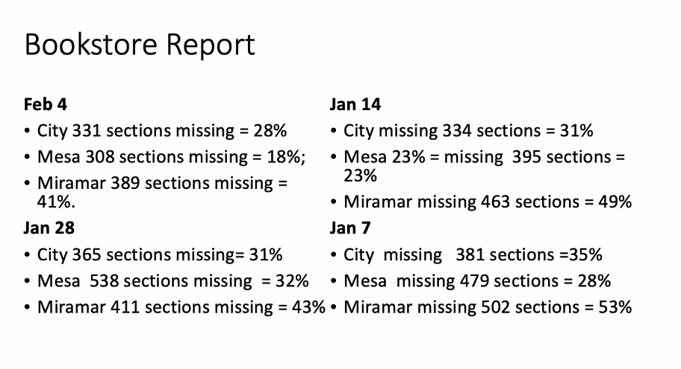
The Bookstores provided the numbers that have affected the ability of students to make an informed choice as they register for their courses. Nancy and her team are working to decrease the number of sections advertised without published costs. Brian noted that we are getting back to pre-pandemic reporting numbers. We are seeing improvement and can credit direct emails and visits with the VPIs and deans and chairs for the improvements. The group discussed reasons for non-reporting sections. Kelly shared that it might help if instructors could manually report ‘no text book required.’ Brian looks forward to updates and clarification at our next meeting.

ZTC Tracker

Desiree reported that they have been working on implementing the ZTC Tracker dashboard and are close to releasing it. City data is there and we are waiting on data from Miramar and Mesa to be included. She anticipates having the tracker live at the end of February and would like to demo the feature at the next meeting.

Next Meeting: Thursday, April 3, 2:00-3:00 pm

Respectfully submitted: Mary Kingsley, SDOLP, District Educational Services

