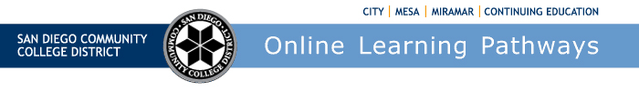

Districtwide Distance Education Steering Committee (DDESC)

Meeting Notes

Monday, September 9, 2024

12:00-1:00

Via Zoom

Members: Aileen Gum, Anagit Traganza, Anne Gloag, Angela Romero, Brian Weston, Brian Palimiter, Cara Smulevitz, Chris Rodgers, Claudia Tornsaufer, Denise Maduli-Williams, Devika Chhabra, Desiree Payne, Donna Eyestone, Ingrid Greenberg, Iris Lowe, Katie Palacios, Kelly Spoon, Kimberly Lacher, Liesl Boswell, Mary Kingsley, Maureen Curry, Michelle Gray, Peter Haro, Peter Tea, Poppy Fitch, Rechelle Mojica, Robbi Ewell, Russ English, Ryan Moore, Sandra Pesce, Sarah Dunn, Stephanie Johnson Shipman, and Tucker Grimshaw

**Meeting Notes**

The group moved to approve the meeting notes for May 4, 2024 without revision. Ingrid moved to approve and Rechelle seconded.

**Welcome/Introductions**

Brian welcomed returning members to the new academic year. He encouraged new members to introduce themselves. Brian welcomed Anagit Traganza, CCE’s new contract Instructional Design coordinator. He also welcomed Ryan Moore, chairman of Miramar’s Distance Education Standards Committee.

**Online Learning Pathways Update**

Online Learning Pathways launched the 2024-2025 *Online Faculty Certification Program* (OFCP) over the summer. Brian thanked Liesl and the team that contributed to updating and restructuring of the OFCP. A reminder that Part 1 - *Teaching with Canvas and Online Accessibility* is a self-paced open-entry course and Part 2 - *Introduction to Online Instruction* will be offered monthly. We are currently running our third cohort of Part 2 - *Introduction to Online Instruction* and all is going well. Once instructors complete both Parts 1 & 2 they are certified and ready to teach online with SDCCD. Liesl reported that our 2023-2024 OFCP program certified 75 faculty. She reported certifications from the colleges at City - 17 faculty, Mesa - 29 faculty, Miramar - 18 faculty, and CCE - 11 faculty. We are hoping with the new version of the OFCP we will have better completion rates. Brian shared that completions for OFCP during FY24 were City 23%, Mesa 39%, Miramar 24% and CCE 15%. We are hoping for higher completion rates with the new facilitated version of the OFCP as it provides monthly monitored cohorts and offers better assistance and support to complete the course.

**Staffing Updates**

***Online Learning Pathways:***

Dean, Brian Weston

Instructional Design Supervisor, Liesl Boswell

Instructional Design Coordinator, Chris Rodgers

Instructional Design Coordinator, Vacant

Administrative Assistant, Mary Kingsley

Brian announced that the District Office of Educational Services has an open Instructional Design Coordinator position for Online Learning Pathways. The position is currently up on the job boards and is being advertised through our DE List Serves; this position will accept applicants through September 23rd. Brian noted that CCE also has an open position for Distance Education Coordinator that closes today.

***2024-2025 Online Faculty Mentors:***

City College – Aileen Gum

Mesa College – Kelly Spoon & Kimberly Lacher

Miramar College – Stefanie Johnson Shipmen

College of Continuing Education – Ingrid Greenberg

***2024-2025 Online Accessibility Mentors:***

City College – Tucker Grimshaw

Mesa College – Kristin Secor

Miramar College – Denise Maduli-Williams

College of Continuing Education – Johanna Gleason

The Online Accessibility website and training calendar is available at <https://www.sdccd.edu/about/departments-and-offices/instructional-services-division/online-learning-pathways-1/faculty/online_accessibility_mentors.aspx> Deka announced that the OAM calendar is synced with OLP calendar.

Brian shared the OLP training calendar at <https://www.sdccd.edu/about/departments-and-offices/instructional-services-division/online-learning-pathways-1/faculty/index.aspx>

Liesl shared that OLP has developed three main workshop *Series* described online:

1. **CAN DO: For Busy Educators Series**We'll cover the essentials of using Canvas, along with some of its special features to help you streamline your teaching and enhance student engagement. Perfect for those short on time but eager to maximize their Canvas skills. Join us and discover what Canvas CAN DO for you!
2. **Ed-Venture Series**This workshop series is all about exploring innovative teaching practices to boost student learning and make your courses a hit with students. Whether you're looking to refresh your approach or try something new, these sessions are packed with creative strategies and practical tips. Join us and take your teaching to the next level!
3. **Za-Za Zoom Series**Join us for a series of workshops where you'll learn how to harness the power of Zoom to elevate your teaching. From designing interactive sessions to creating a strong learning community, we'll show you how to make the most of Zoom's features to engage your students like never before. Don't miss out!

Online Learning Pathways is offering three new *types* of workshops described on our website:

**Click-A-Long**This hands-on session lets you work on your course in real-time while following along with guided instructions. Bring your laptop, and as we explore features and strategies, you'll click along and apply them directly to your course. It’s the perfect way to learn by doing and leave the workshop with tangible progress!

**Demo**We'll be showcasing new applications and processes that can elevate your teaching experience. You'll get a firsthand look at how these tools work, with step-by-step guidance on how to integrate them into your own courses. It's a great opportunity to see the latest innovations in action and ask questions along the way!

**Community/Panel**This is your chance to engage with fellow educators in a collaborative space where we’ll discuss key topics, share insights, and explore different perspectives. Whether you have questions, ideas, or just want to listen in, this workshop is all about open dialogue and learning from each other. Everyone’s voice is welcome!

Brian added that along with our current list of workshop offerings, SDOLP staff will also be visiting each campus for face-to-face opportunities with Hyflex training workshops throughout the semester.

Anagit questioned availability for salary advancement with the OFCP course. Mary shared that the OFCP allows credit for Part 1 = 5 hours flex credit, and Part 2 = 15 hours flex credit for a total of 20 hours flex credit. The faculty contract currently states that thirty (30) hours of professional development workshops equal one (1) semester unit. If the OFCP is used for salary advancement it cannot be used towards FLEX credit. Mary directed Anagit to the [AFT-Guild, Local 1931 - Faculty](https://www.sdccd.edu/docs/HumanResources/employee%20relations/Collective%20Bargaining%20Agreements/Current%20CBA%20Handbooks/SDCCD%20Faculty%20CBA%20AGREEMENT_24-0118_Revised.pdf) [Collective bargaining Agreement 2023-2024](chrome-extension://efaidnbmnnnibpcajpcglclefindmkaj/https:/www.sdccd.edu/docs/HumanResources/employee%20relations/Collective%20Bargaining%20Agreements/Current%20CBA%20Handbooks/SDCCD%20Faculty%20CBA%20AGREEMENT_24-0118_Revised.pdf)  for information regarding salary advancement. Section 7.13.7 and A4.3.5 pictured below:

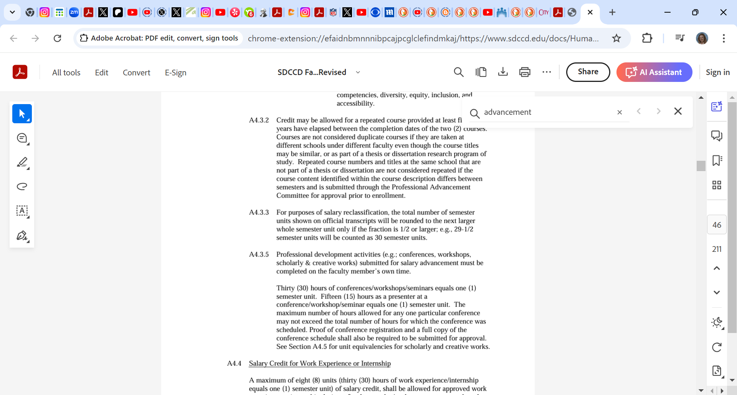

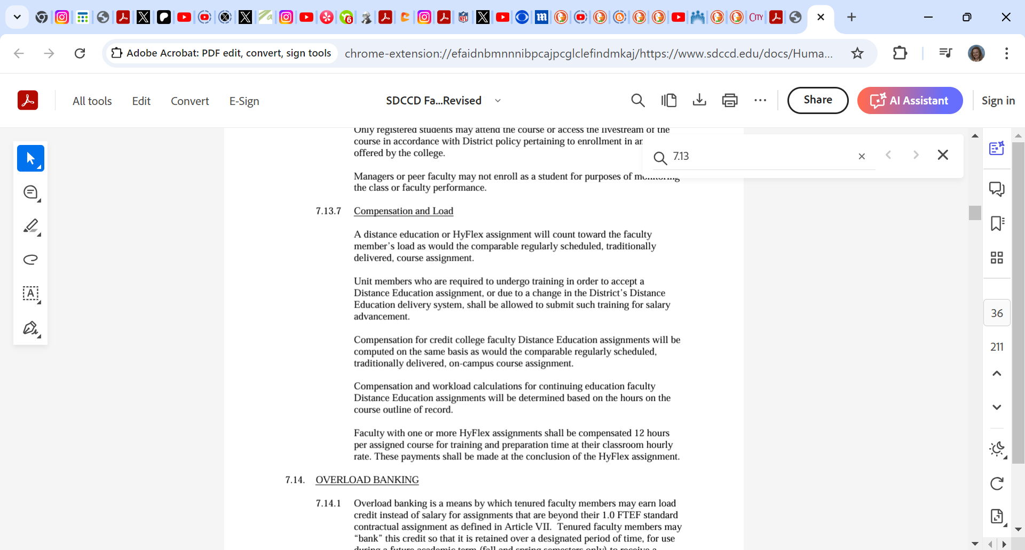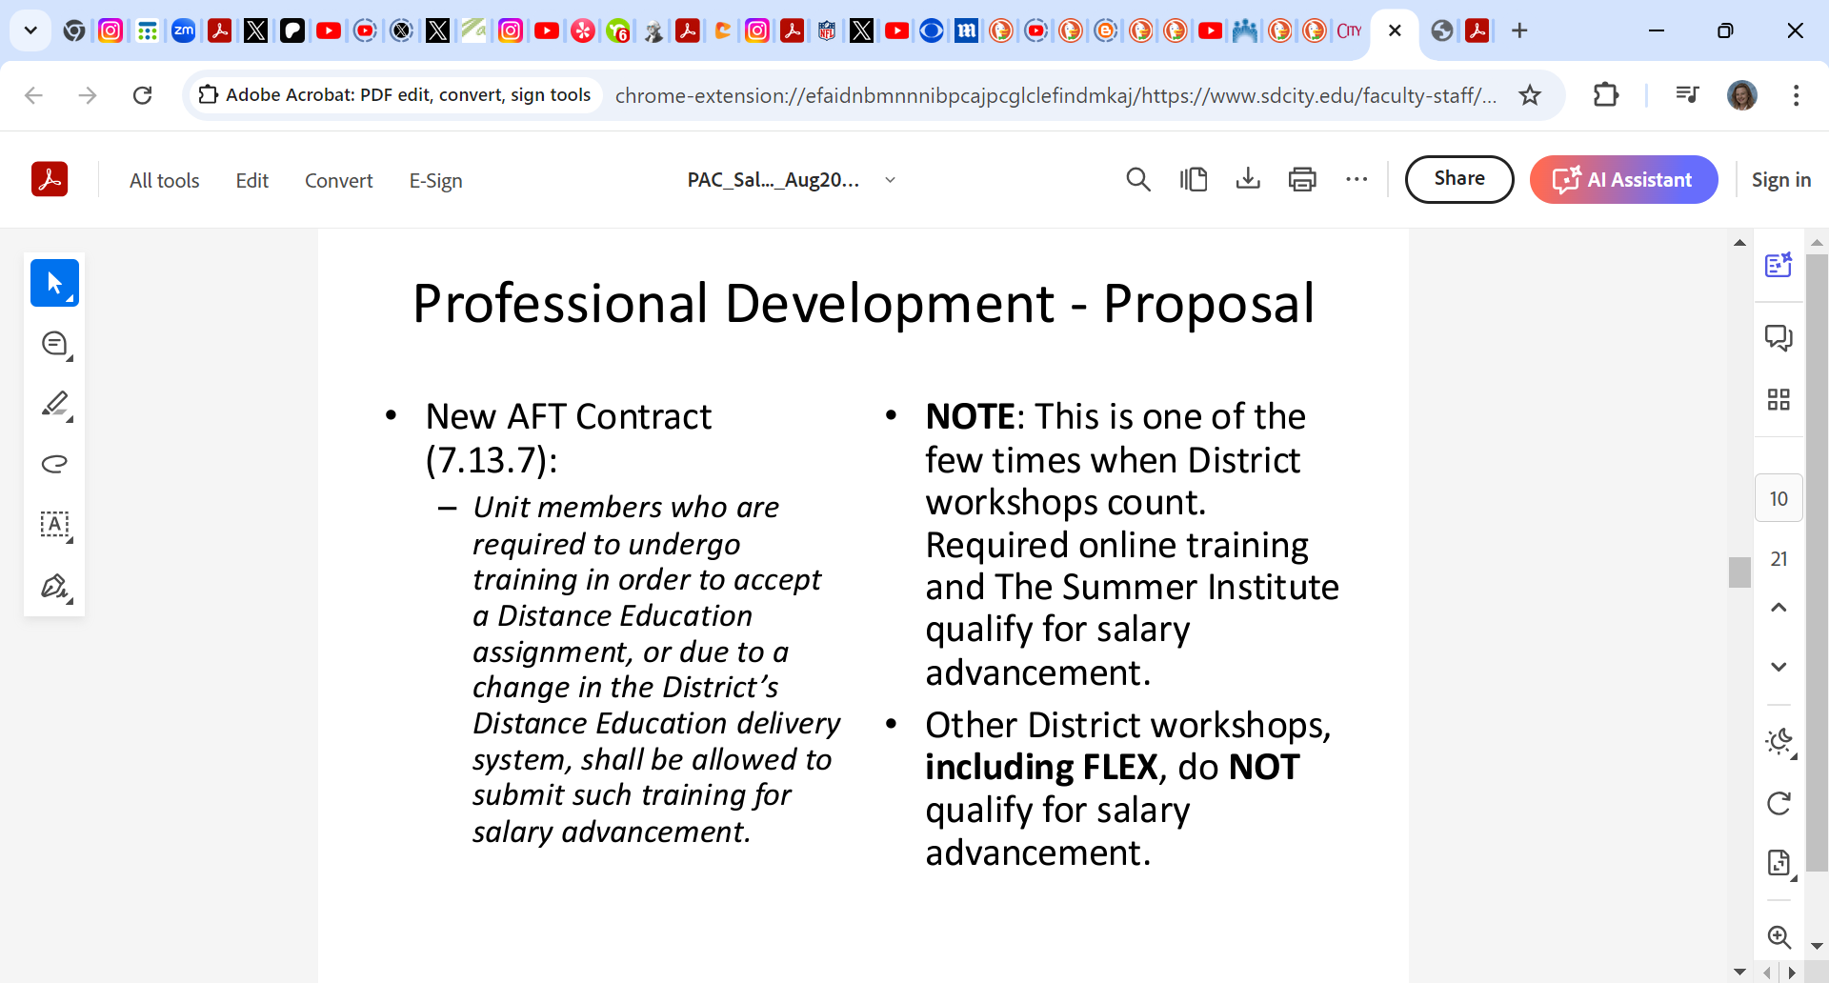

**Canvas Discussions**

The new *Canvas Discussions* has been rolled out for all Canvas users. New features include, UI for accessibility, flexible viewing options, including inline and split view, quoting functionality, improved search with highlighting, anonymous discussions, and additional sorting and filtering.

Rechelle asked if they have made speech-to-text available *when responding* in Discussions. Deka shared that it may be dependent on the device used by the student. Katie shared different ways instructors can model good behavior. Rechelle would like to see Multiple Due Dates enabled, Liesl said that Instructure is working on it. Brian shared that there is a new *AI Discussion Summary* feature available to instructors. Also, there is a new way to build pages in Canvas using a design-editor tool that provides a template; this tool is not quite ready. Canvas hopes to save instructors time building courses. Brian added that Citilabs is good at building templates, but only CCE has purchased that tool.

**ACCJC**

The ACCJC has [DE Resources and Rubric Feedback Survey](https://survey.alchemer.com/s3/7969398/Pilot-Distance-Education-Resources-and-Rubric-Feedback) available until November 15. The ACCJC is looking for feedback on how they can provide continuity in online course design with RSI. They have noted that they need a *guiding standard* because different colleges are getting flagged for different issues. They are asking for 50 members to review 3 topics according to a rubric. They are asking for feedback from everyone at

<https://survey.alchemer.com/s3/7969398/Pilot-Distance-Education-Resources-and-Rubric-Feedback>

**Zoom and Retention**

CCC TechConnect [*Zoom Recordings and Transcripts Retention Policy*](https://ccctechconnect.zendesk.com/hc/en-us/articles/27525579641883-Zoom-Recordings-and-Transcripts-Retention-Policy) is being updated. The new policy will go into effect October 2025. Zoom recordings and transcripts stored in Zoom's cloud for CCC TechConnect sub-account users (faculty, staff, admins) shall be systematically deleted one year after their recording date.Brian shared that zoom recordings can be stored in Canvas Studio, 3C Media, and OneDrive. We will also offer workshops to faculty to offer storage alternatives on different platform.

**Announcements:**

* SDCCD 2024 Distance Education Summit – October 4, 2024 8:00am-2:00pm HYFLEX Open to all faculty. Light breakfast and lunch. Additional information as date grows closer.
* OpenEd is hosting Hyflex October 8-10, 2024
* OTC June 16-18, 2025

**Next Meeting**

Next meeting is scheduled for Monday, October 7, 2024 from 12:00pm-1:00pm.

*Respectfully submitted: District Office, Educational Services, Mary Kingsley*