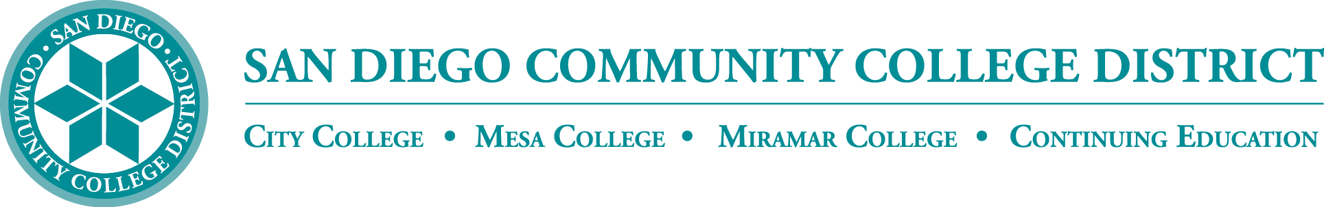

**District’s Educational Services Software Workgroup**

**April 18, 2024**

**11:00 a.m. – 12:30 p.m.**

**Meeting Notes**

**Members:**

Aaron Detty, Aaron Iffland, Aileen Gum, Amertah Perman, Anne Gloag, Brian Weston (Chair,) Cara Smulevitz, Charlie Lieu, Cheryl Reed, Claudia Tornsaufer, Darius Spearman, Denise Munoz, Elizabeth Barrington, Ingrid Greenberg, Isabel O'Connor, Jay Pope, Jill ODea, John Bromma, Katie Palacios, Kelly Rosas, Laura Murphy, Ljubisa Kostic, Manuel Velez, Matilda Chavez, Matthew Rivaldi, Maureen Curry, Michelle Fischthal, Monica Romero, Nancy Wichmann, Paul H. Alexander, Peter Haro, Peter Maharaj, Poppy Fitch, Rechelle Mojica, Robbi Ewell, Russ English, Star Rivera-Lacey, Stephanie Lewis, and Stephanie Major. *Academic Senate Presidents:* Andrew Hoffman, Paul Alexander, Paul (Pablo) Martin, and Richard Weinroth

**STAC-STARTE**

The state negotiates packages and prices for common software across the state. The purchasing window is currently open if you are interested in any of the produces listed below:

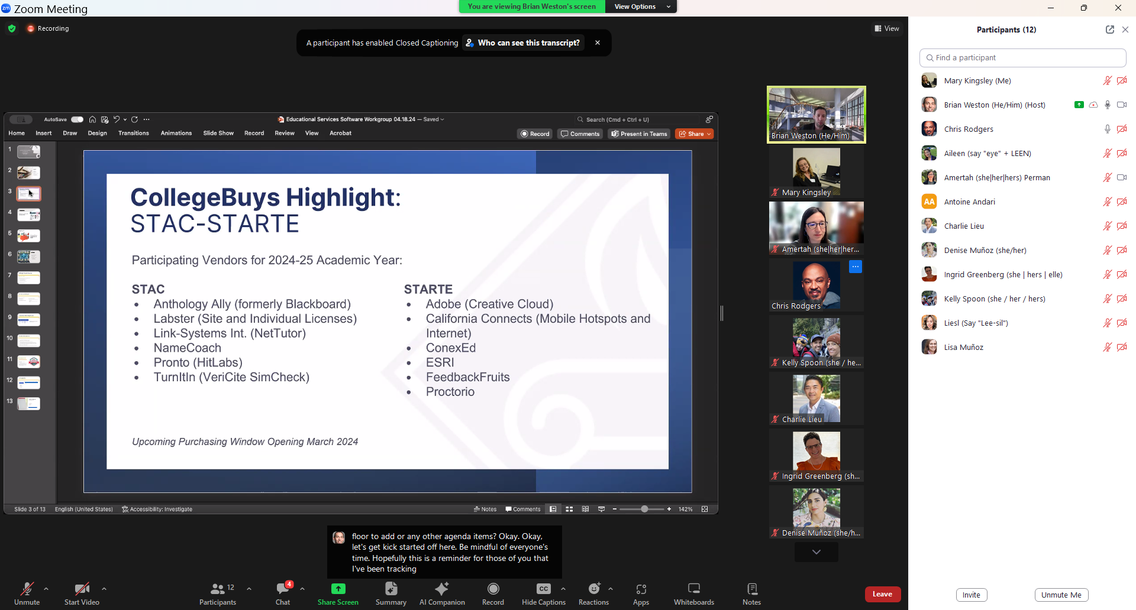

**Handshake**

Dean, Amertah Perrman presented the District’s ‘Handshake.’ Handshake is the districtwide job board. SDCCD has renewed our Handshake contract through 2029. The District implemented Handshake in Fall 2021 with our first upload of students in 2022. We have been working on *awareness campaigns* for faculty, staff, and students. The job board is part of the career-package services offered at each college services. All of the colleges are working on including *career-focused events* into Handshake. Some colleges are exploring the *appointment feature* which alllows students to make appointments for career services and counseling services.

There are additional features that are currently not in use, such as the tools support destination survey and employer tools. All of the Handshake Leads have asked to work collaboratively across the colleges. This is a reminder for us to become familiar with and use the Handshake across the district. There is a student-facing website we continue to develop and hope to build out. We are also working with District HR to post SDCCD employment opportunities. The District training is in process now and we hope to have this available soon. The Handshake team will begin planning for 24-25 in the next months.

Amertah provided the April 2024 Handshake Update below:

**Handshake Software Update**

**Reminders:** Handshake is the San Diego Community College District’s Job Board – an online platform for Employers and Students. As the nation’s number one college-to-career network, Handshake provides a one-stop shop for employers to engage students, post jobs, and hire. It also provides an easy to manage engagement system to track employer engagement across multiple roles – minimizing duplication across colleges and improving the employer experience.

* Districtwide commitment to the platform and purchase: 2020-2021
* Establishment of Districtwide Implementation Team: Fall 2021
* First student upload: 2022
* [November 2022 ESSW Update](https://www.sdccd.edu/docs/ISPT/workforce/docs/ESSW-Handshake-Update-Nov2022.pdf)

SDCCD students can login to one account across all four campuses, removing barriers to employment opportunities and making career support a priority along with their education. All actively enrolled students are uploaded into Handshake monthly – they just need to activate their account. Once activated, they have access to job postings and employer events.Handshake Activity as of April 15, 2024:

Total Student Activations: 3,963

• City - 1,815

• Mesa – 2,874

* + Miramar – 1,820
  + Continuing Education – 1,362

Total Employer Approvals: 7,444

* Total Active Paid Job Postings from Approved Employers: 17,253

# College Commitments

* Student Activations – Commitment to developing local, college-specific awareness strategies to increase student activations and college-wide awareness of the tool.
* Handshake provides a great opportunity to recruit and retain students – making

job placement and employability a key part to every student’s experience.

* + Colleges encouraged to:
    - Take an institution-wide approach to handshake with a focus on integration throughout the complete student journey. Awareness campaigns for faculty and staff are encouraged.
    - Add Handshake to Canvas.
    - Train Outreach Coordinators and Ambassadors and other roles on Handshake and the benefits to students.
* Events – Commitment to posting all career related events within Handshake

o Enables promotional and check-in features, as well as data insights

* Exploration of the Appointments feature - Handshake includes a career services appointments function for students to connect with job placement coordinators, career guidance counselors, internship and work-based learning professionals. Colleges are in different phases of exploration and implementation of this feature. Colleges already using the feature are seeing positive results with students from all colleges requesting appointments

**Additional Features:** Handshake has expanded features included destination survey resources and employer engagement tools. Handshake leads interested in leveraging these components are encouraged to connect locally with their research office (regarding destination survey) and employer facing roles to explore possible applications.

# District Support for Districtwide Implementation and Use of Handshake

* New districtwide support role (Career Services Admin Tech)
* District monthly uploads of enrolled students
* Data cleanup and integrity
* Integration with Campus Solutions and My SDCCD Portal
* Districtwide student facing website

o Colleges encouraged to have local pages as well!

* Districtwide Reporting – weekly counts provided to Handshake leads
* Facilitation of Districtwide Implementation Workgroup
* District Employee Services engaged – training in process; will be posting all NANCE positions and on campus postings
* Approved on campus posting model (March 2024)
  + 5 SDCCD Domains Development – one per college and the district
  + Employee Services has access to post jobs for all 5 domains
  + Additional access to post within these domains will be determined by each college
    - HCM leads encouraged to connect with their college’s Handshake

leads to explore options

* + - Individual office, school, or department leads could be given permission to post on campus positions

# Districtwide Implementation Workgroup:

* Implementation team meetings monthly; includes representatives from all four colleges
* Shared Teams folder with resources, trainings, tools, and support
* Meeting agendas, key contacts, and reference materials available [online](https://www.sdccd.edu/about/departments-and-offices/instructional-services-division/workforce-and-economic-development/Career%20Services.aspx) and in Teams
* 2024-25 Planning in process
* Areas of exploration:
* Districtwide Faculty Access
* Payment feature within platform o Refined monthly upload process o Expanded reporting

# Handshake Leads:

* City: Roger Sanchez
* Continuing Education: Franklin Garrett
* Mesa: Olivia Picolla
* Miramar: Alex Ortega Jr.
* District: Educational Services Division, Career Education & Workforce Development - Noah Lacsina, Career Services Admin Tech

**Single Sign On Canvas**

Several meetings have been held across the district. Single Sign On will go live on July 15. All users will be logging in with the ‘SDCCD’ email. We are working on a soft launch during the summer to avoid disruption. Brian offered help to campuses that need support with the new sign on. Students will have a one-spot hub which will also help us provide a more secure login with a multi-factor authentication. MySDCCD is set to launch in 2025.

Aileen reported that we have logins with our email address and other sites that use our email address without ‘@sdccd.edu.’ She experiences the same issues with City WiFi login. Antione said that he will check in on this issue.

**MyApps**

Brian shared the MyApps dashboard. The link can be found under the District’s O365 page at <https://www.sdccd.edu/about/departments-and-offices/human-resources/it/office-365/myapps-sdccd.aspx> or <https://myapps.microsoft.com/>

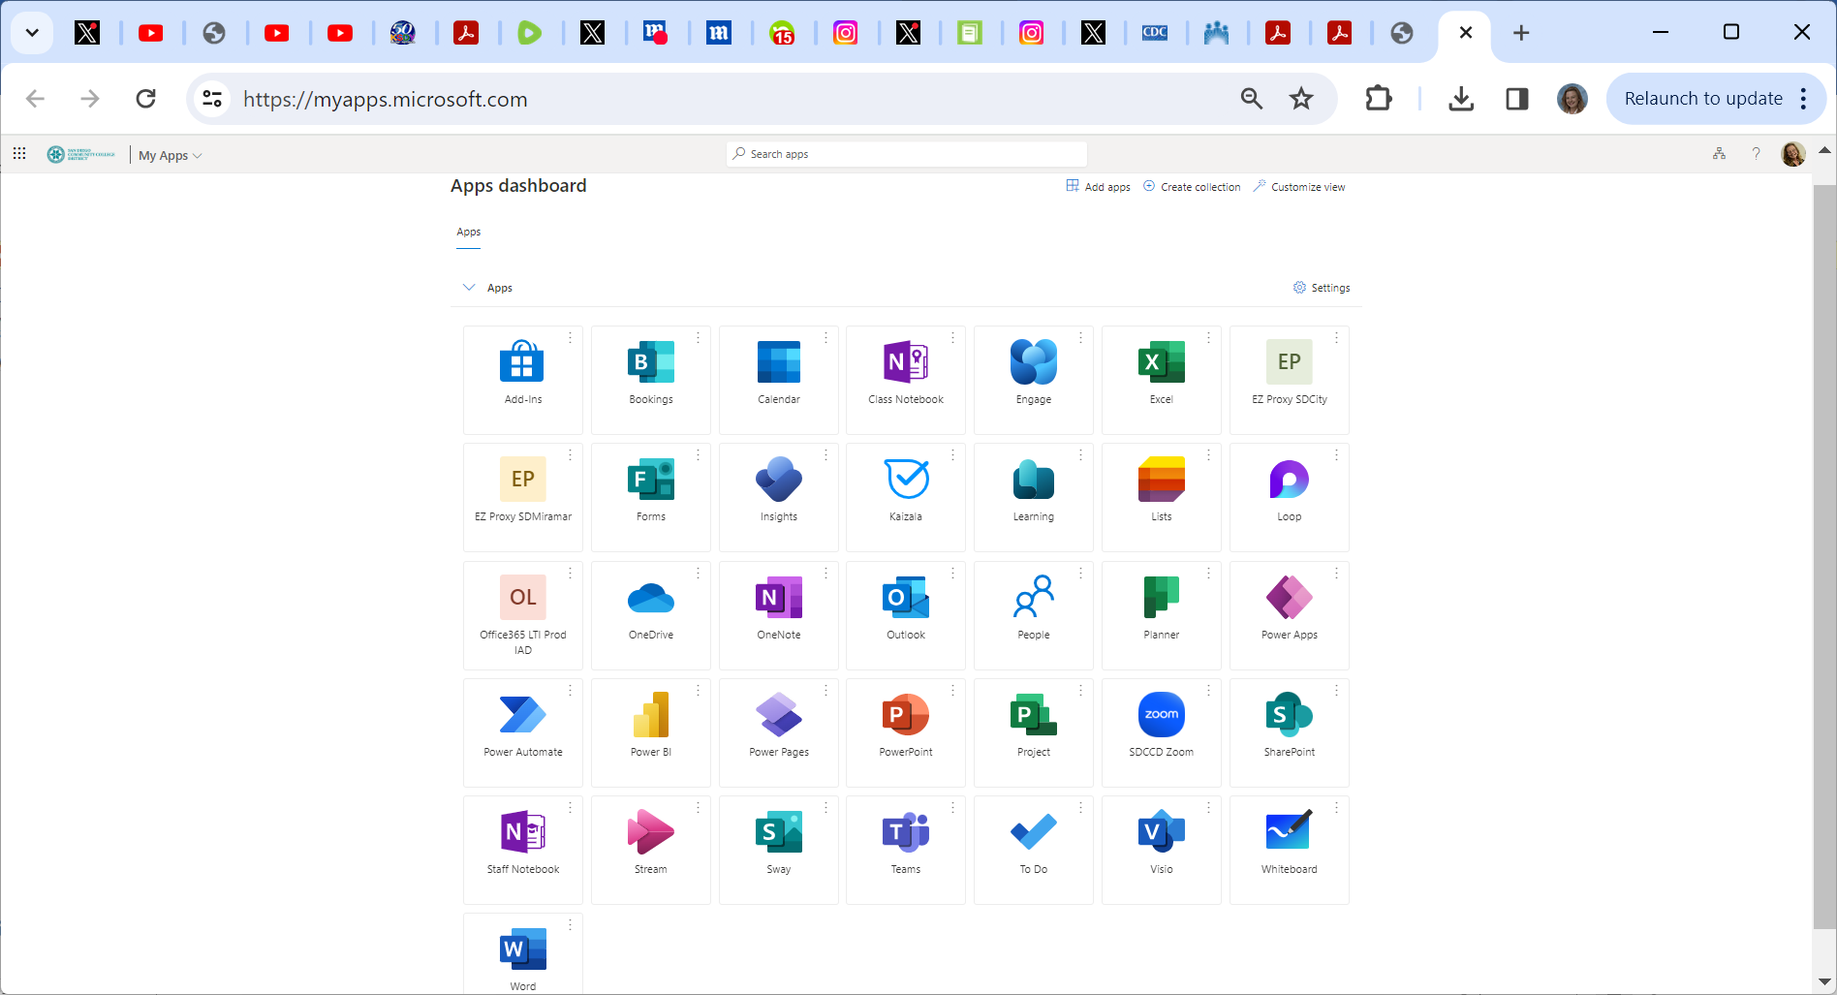

**AI Tools**

We continue to keep up to date with AI Tools. We have executed several surveys that have produced mixed results. Brian asked for reports from the colleges. Aileen reported that faculty continue to use TurnItIn.There have been issues with students and those are being addressed individually. Kelly reported that Mesa’s newsletter addressed many current concerns. Monica shared that Mesa has a meeting tomorrow and will be addressing the AI issue. Lisa reported that Miramar has Rodrigo facilitiating workshops with great information that have been well received. Ingrid reported that CCE instructors are finding that students are using AI in discussion postings. Also, she noted that CCE has not crafted any syllabus language to date. She mentioned that different industries are looking Pace.ai that could help write curriculum. Pace.ai helps with pronunciation. She shared from AFT <https://gptzero.me/news/gptzero-partners-with-american-federation-of-teachers-aft-to-support-responsible-ai-adoption-in-classrooms>. Aileen shared that *Blue Canoe* does a good job with ESL vowel pronunciation (free app) with a higher paid version; *Zengengo* does a fairly good job for multi-skills with a pronunciation (sentence level) among other choices (not just ESL), it has a free trial period, but is a paid subscription.

Brian announced the *Proposed AI Syllabi Language* <https://sdccd0-my.sharepoint.com/:w:/g/personal/bweston_sdccd_edu/Ea3dRE0FKbRPik5up7dpZSQBIiR6-gyRSP009odXYj9a9w?e=GnplOD>

Brian thanked Rodrigo and VC Fischthal for their participation and promotion of AI across the district. SDSU held the largest student survey on AI tools with 7,811 participants shown below:

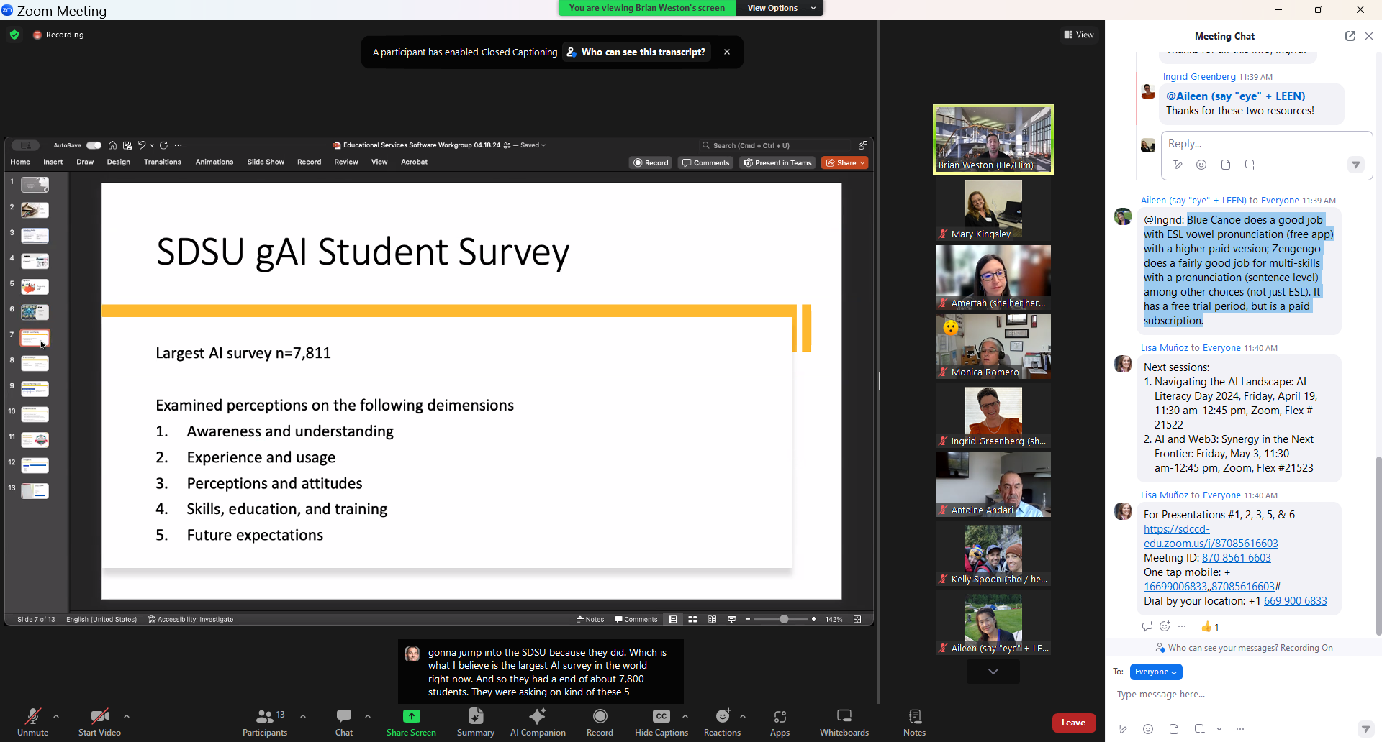

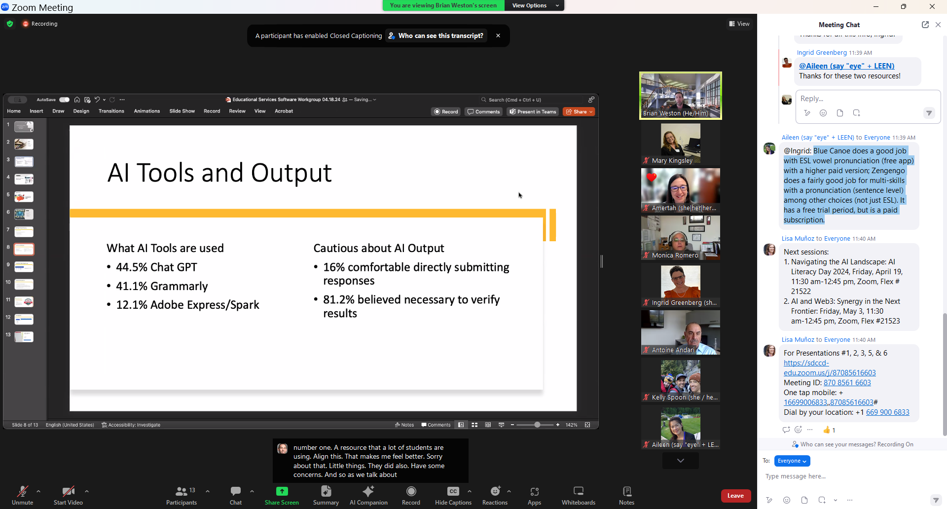

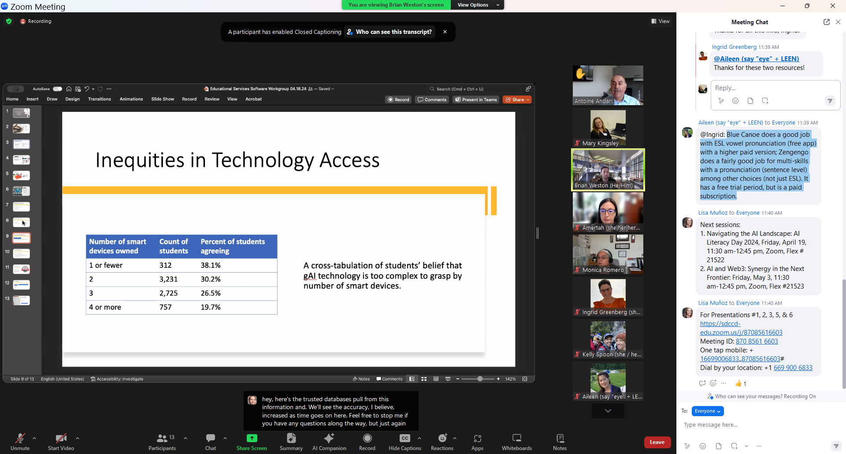

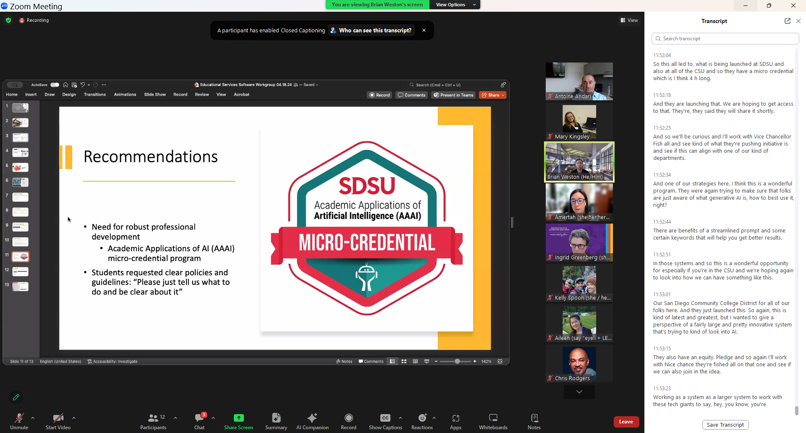

**LTI 1.3 Upgrades**

The LTI standards are moving from LTI1.1 to LTI 1.3. Canvas will only accept LTI.3. Canvas will only support LTI 1.3: Publishers, Zoom, CitiLabs, PopeTech, and TurnItIn.

**Next Meeting:** September TBA, 2024

*Respectfully submitted by: Mary Kingsley, Educational Services*