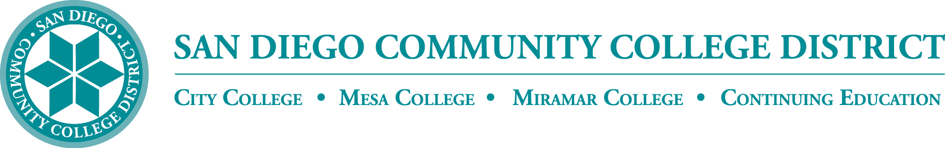

**District’s Educational Services Software Workgroup**

**September 19, 2024**

**12:00 – 1:00 p.m.**

**Meeting Notes**

**Members:**

Aaron Detty, Aaron Iffland, Aileen Gum, Amertah Perman, Anagit Traganza, Anne Gloag, Brian Weston (Chair,) Cara Smulevitz, Charlie Lieu, Cheryl Reed, Claudia Tornsaufer, Darius Spearman, Denise Munoz, Elizabeth Barrington, Ingrid Greenberg, Isabel O'Connor, Jay Pope, Jill ODea, John Bromma, Katie Palacios, Kelly Rosas, Laura Murphy, Ljubisa Kostic, Manuel Velez, Matilda Chavez, Matthew Rivaldi, Maureen Curry, Michelle Fischthal, Monica Romero, Nancy Wichmann, Paul H. Alexander, Paul Corigliano, Peter Haro, Peter Maharaj, Poppy Fitch, Rechelle Mojica, Robbi Ewell, Russ English, Star Rivera-Lacey, Stephanie Lewis, and Stephanie Major. *Academic Senate Presidents:* Andrew Hoffman, Paul Alexander, Paul (Pablo) Martin, and Richard Weinroth. Observing: Mona Alsoraimi Espiritu

**Committee Overview**

Brian welcomed the group to the first meeting of the year. He recognized that there are similarities and some overlap with other group being formed in the District Technology Committee. ESSW formed right after the pandemic to review instructional *software purchases* and participate in discussions of different software products available. We are a very large community college district and we have leverage when it comes to negotiating with our partners. We also wanted to make sure we have transparency, so we developed a web page for district staff to help them understand what is available to them. ESSW has successful brought extended contracts for software in use for longer periods. ESSW will track along with other technology groups to make sure we are serving everyone's needs.

Overall our goal is to improve outcomes for district students. The purpose of the technology should be primarily to help our students be successful, and allow our faculty to teach in different modalities. Brian shared how some software is used and developed at the college level and after a pilot period is brought to this committee to see if it could be a benefit districtwide.You can visit the [*Online Learning Pathway’s* Software & Products webpage](https://www.sdccd.edu/departments/educational-services/online/faculty/sdccd_software_and_products/index.aspx):

[**Canvas Studio**](https://www.sdccd.edu/departments/instruction/online/faculty/sdccd_software_and_products/canvas_studio_editing.aspx) - Communication tool allows instructors and students to actively collaborate through video and audio media. Funded through OEI until 6/30/2026.

[**Play Posit**](https://www.sdccd.edu/departments/instruction/online/faculty/sdccd_software_and_products/playposit.aspx) **-** Communication tool allows instructors and students to actively collaborate through video and audio media. Funded through TechConnect until 6/30/2024.

[**Canvas LMS**](https://www.sdccd.edu/departments/instruction/online/faculty/sdccd_software_and_products/canvas_lms.aspx) **-** Online Learning Management System can be utilized to host online classes for grading, assessment, and communication. Funded through State CCC.

[**Microsoft Office 365**](https://www.office.com) - Office suite that includes Word, PowerPoint, Access, Excel, and OneDrive for file storage. Funded by SDCCD.

[**Pronto**](https://pronto.io/) - Communication hub created for the everyday user. It connects students, teachers and entire campuses via chat and video, so they can learn faster, work smarter, and communicate seamlessly. Funded by SDCCD colleges through 6/30/2026.

[**TurnItIn**](https://supportcenter.turnitin.com/s/) - Plagiarism checker can be utilized to verify the originality of submitted texts or documents and delivers detailed similarity reports to instructors and students. TurnItIn Similarity funded until 6/30/2026

[**ConferZoom aka SDCCD Zoom**](https://www.ccctechconnect.org/) **-**- Online platform can be utilized for video and audio conferencing, chat, and webinars. Funded through CCC TechConnect.

[**PopeTech**](https://pope.tech/) - Accessibility tool built into the Canvas system that allows content to be checked for accessibility. Funded through CCC TechConnect.

[**NetTutor**](https://www.nettutor.com/)- Online tutoring service provides 24/7 Math and English tutoring support, along with multiple other subjects. NetTutor is accessed by students within Canvas.  Funded through Chancellors Office 250 Hours until 6/30/2024.

**Instructional Software Survey**

To help gain an understanding of faculty software use, a survey is conducted through IR’s that evaluates the usefulness of software such as Canvas and Zoom. Earlier this year, VC Fischthal shared the results from the *Fall 2023 Employee Survey on Innovative Practices and Emerging Technologies*. There is planned to be another survey going out this year from IIE regarding AI use among faculty, staff,and students. The results should help build conversations around what tools should be evaluated and/or adopted. Some of these conversations are larger than educational services and would include the district as a whole. Brian asked all to participate when the surveys become available.

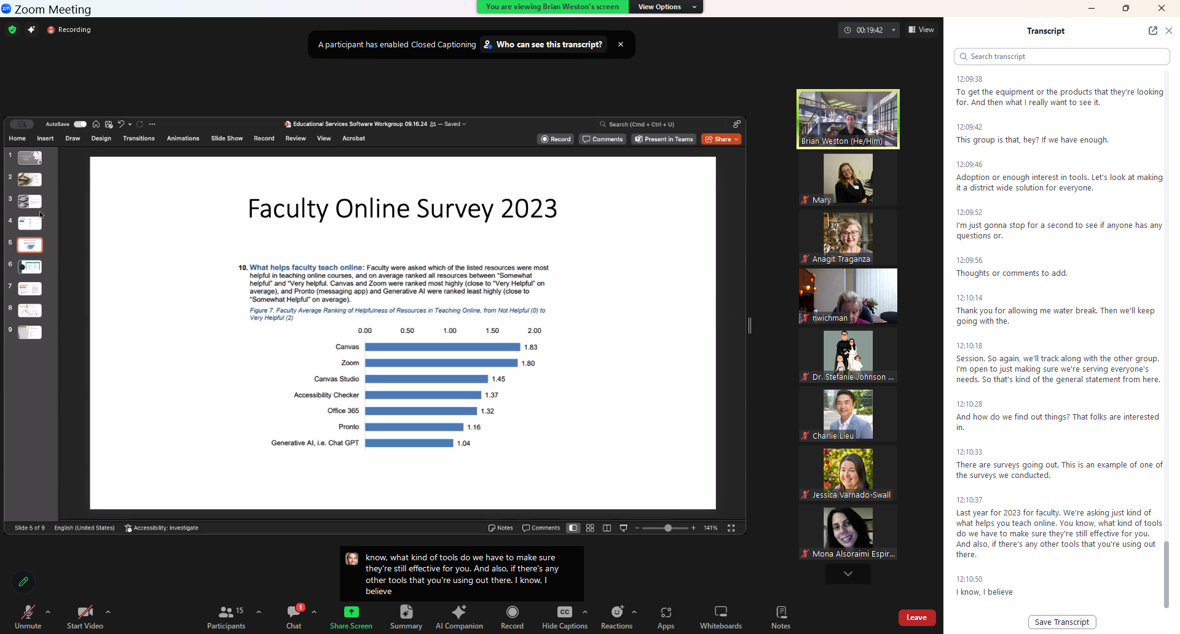

**Support and Professional Development**

*Online Learning Pathways* offers professional development opportunities for faculty on districtwide use of tools such as Canvas, Zoom, Pronto, and AI workshopsw. Also, Online Faculty Mentors and Online Accessibilt8y Mentors are offering workshops throughout the semester. You can view the workshop schedule from the OLP and Accessibility PD calendar: <https://www.sdccd.edu/departments/instruction/online/faculty/index.aspx>

**Zoom Recordings**

CCC TechConnect [*Zoom Recordings and Transcripts Retention Policy*](https://ccctechconnect.zendesk.com/hc/en-us/articles/27525579641883-Zoom-Recordings-and-Transcripts-Retention-Policy) is being updated. The new policy will go into effect October 2025. Zoom recordings and transcripts stored in Zoom's cloud for CCC TechConnect sub-account users (faculty, staff, admins) shall be systematically deleted one year after their recording date.Brian shared that zoom recordings can be stored in Canvas Studio, 3C Media, and OneDrive. We will also offer workshops to faculty to offer storage alternatives on different platforms.

**Online Whiteboarding**

Google will be decommissioning *Google JamBoard* on December 31, 2024. They have already started to wind down support. An alternate online whiteboarding solution, Lucid provided by Instructure, will be reviewed*.*

**Announcements**

*Online Learning Pathways* will be hosting SDCCD’s DE Summit on Oct 4th from 8:00am--2:00pm at CCE’s North City Center and Online via Zoom. Please check your email for the invite and RSVP.

**Next Meeting**

Next meeting is scheduled for Thursday, October 17, 2024 from 12:00pm-1:00pm.

*Respectfully submitted: DO, Educational Services, Mary Kingsley*